Volcania



Automobiles

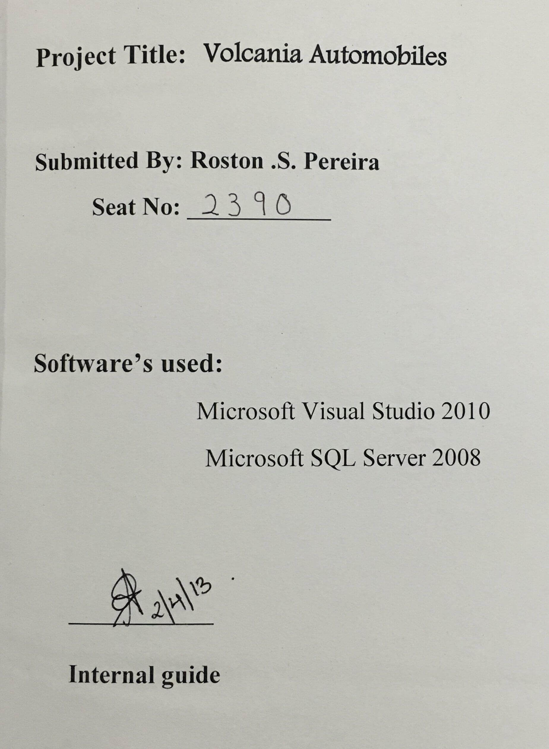

**Acknowledgement**

**E-Business Auto Marketing System**

Before getting to the depth of this project I will like to express my thanks to all the faculties of **St Andrew’s college** for their unending support throughout the project. This project would not have been a success without your support.

I express my deep sense of gratitude and warm thanks to my project guide Prof: **Anubha Singh,** for her guidance throughout the project.

# **Index**

|  |  |  |
| --- | --- | --- |
| Serial Number | Topic | Page Number |
| 1 | Synopsis | 1 |
| 2 | Problem Definition | 4 |
| 3 | System Analysis and Design | 7 |
| A | Model | 11 |
| B | Requirement Analysis | 14 |
| 4 | Project Profile | 18 |
| A | Hardware and Software Requirements | 19 |
| B | Need of the Language | 20 |
| 5 | SDLC | 28 |
| A | DFD | 30 |
| B | ERD | 35 |
| C | Gantt Chart | 37 |
| D | State Transition | 40 |
| E | Use Case | 43 |
| F | Pert Chart | 46 |
| G | Activity Diagram | 48 |
| H | Sequence Diagram | 49 |
| I | Data Dictionary | 52 |

|  |  |  |
| --- | --- | --- |
| Serial Number | Topic | Page Number |
| 6 | System Implementation | 58 |
| 7 | Testing | 62 |
| 8 | Maintenance | 67 |
| 9 | Screenshots | 70 |
| 10 | User Manual | 86 |
| 11 | Future Scope | 90 |
| 12 | Conclusion | 93 |
| 13 | Bibliography | 95 |
| 14 | References | 96 |

***Synopsis***

# **Introduction**

E-Business Auto Marketing System offers online solution for dealers to connect with the most qualified buyers shopping for new vehicles by providing the following features:

* Buy: Connect with dealers to buy new cars and bikes.
* Research: Compare features, get pricing information, read reviews and more.

Millions of vehicle shoppers visit these systems each month which connects a buyer and a seller every fraction of seconds. This proposed web based application framework “E-Business Auto Marketing System” as outlined above is an attempt to provide a fastest-growing automotive marketplace for buyers and dealers. It will be the destination for those looking to buy a new car or bike. With the vehicle listings from nearly hundreds of Automobile companies nationwide with classified advertising and it will offer the best selection of new cars and bikes online, as well as the content and advice to support the shopping experience. This system will help to grow and strengthen the relationship between registered auto classified dealers (Suppliers) and consumers (buyers, visitors, site surfers etc.) While providing its users with the best online auto shopping experience.

It will offer following features to its users:

* **Consumer:**

Consumer features include the following:

Search option such as search a new car by name, model or make etc. search specific dealers inventory to find all available models. Compare cars to find the best suitable car and details of loan facilities and an option to book for a Test-drive. Consumers can book a car or bike with some initial amount and can customize their car (only available for selected companies) as per their requirement. Consumers get a complete view of a car, the colors available, exterior/interior of the car, the price etc.

* **Dealer:**

Dealer features include the following:

Classified simple inventory management, update inventory anytime anywhere. Ease to advertise the models, track vehicles that have been booked and respond to leads.

***Problem Definition***

***The problems faced and the solutions over the existing system:***

* The transactions related to booking request are maintained manually at present along with maintaining the accounts of test drive request and other related works.
* The application should provide quick access to the records maintained and must reveal the important reviews about the business so that the growth can be easily compared and should provide with various reports showing the related details so that the important decisions could be taken easily.
* The E-Business auto marketing system implements database to make the existing system more efficient.
* It is difficult to keep the paper records and use them in the future, but the E-Business auto marketing system solves this problem by providing and storing all the records in the database which can be retrieved and used anytime in the future.
* When a car or bike is to be booked, the details are entered into the E-Business auto marketing system.
* In the conventional method for buying a car or bike, the consumer has to visit a showroom and check for each car or bike. Plus the showrooms had only limited colors and model for display.
* Through this software any customer can search a bike or car with its name and compare two different cars or bikes from any location and at any time.
* In the conventional method all the records of test drive request were paper recorded, which were difficult to maintain and time consuming in case the administrator had to check the older records (records of one year or more). This software makes searching of records easy and maintain it well.

***System Analysis and Design***

* ***Existing system:***

An auto classified system offers solution for dealers to connect with the buyers shopping for new vehicles. All active entities including dealers and sellers cannot maintain theirs accounts, inventories and associated photo galleries. In order to support sellers, this system does not facilitate sellers to place ads online for their vehicle. The framework also does not support booking vehicles online. The system does not have a site messaging system tool that can be used seamlessly in any web application. To overcome above problems we are implementing a web based application framework “E-Business Auto Marketing” which attempts to provide a fastest growing automotive marketplace for buyers and dealers.

* **Limitations of existing system**

1. Lack of data security
2. More manpower
3. Time consuming
4. Needs manual calculations
5. No direct role for the higher officials

* ***Proposed system:***

Proposed system is E-Business Auto Marketing System. Our project E-Business Auto Marketing System aims at developing an application framework that is centered on enhancing and facilitating the buying and selling experience amongst the different entities involved in the E-business of automobile.

With this application, site visitors can search a car by its make or model that are available with the dealer and independent sellers. This application framework combines powerful search features for both cars and bikes with pricing information, separate photo and side-by-side comparison tools.

* **Our proposed system has the following advantages:**

1. User friendly interface
2. Fast access to database
3. Less error
4. More storage capability
5. Search facility
6. Comparison tool
7. Look and feel environment
8. Quick transaction

All the manual difficulties in managing the automobile business have been rectified by implementing computerization.

***Objective of the system:***

The main objective of this application is to automate the existing system of manually maintain the records of booking a cars and/or bike, booking for a test drive, compare and search to be computerized.

# Model:

**Iterative Waterfall Model**

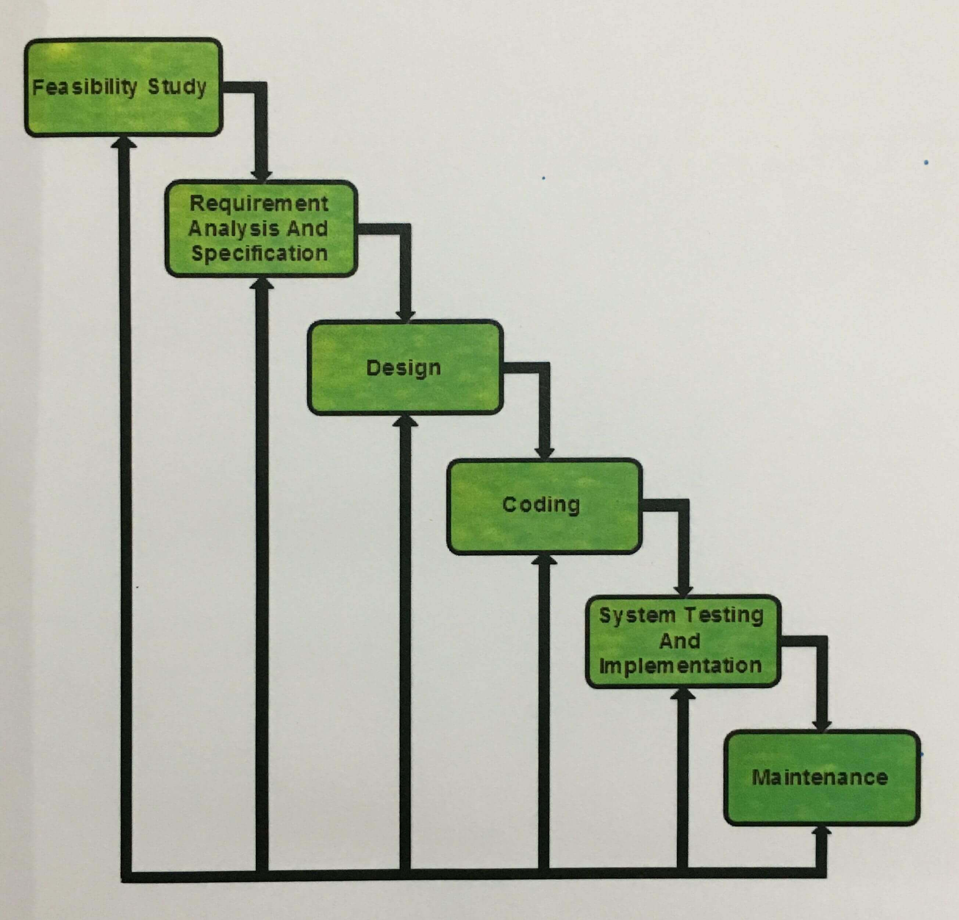

The classic waterfall model is an idealistic one, it is not a practical one. During the course of development, there is enough scope for errors. The reasons may be due to wrong assumptions, use of inappropriate technology and communication gap between users and developer throughout the cycle. These defects get detected much later during the life cycle and then it is very difficult to redo the work and correct these defects. Hence the next model which evolved was the Iterative Waterfall Model.

This model combines elements of waterfall model applied in an iterative fashion. The iterative model applies the steps of the waterfall model in incremental steps and then a feedback path from every phase to its preceding phase is introduced that helps in getting the feedback from the customer and detect errors and solving them before proceeding to the next phase.

* **Benefits:**

At every phase, project review is conduced that helps in understanding whether, the effort is being made in the right direction. This model helps in detection of errors and resolving them at every phase before we proceed to the next phase.

This method detects errors as close to the points of introduction as possible is one of the important principles of software engineering called face containment errors.

* **Drawbacks:**

In spite of best efforts put in to detect errors in the same phase in which they are committed, some errors do escape detection and may get noticed only in the later phase.

This model does not take care of the different types of risk that real life software project is subjected to.

This model makes a rigid adherence to the waterfall model which actually creates blocking states in the system. Team members will have to wait for a phase to complete before they can start their next activity.

# Requirement Analysis:

An automobile database needs to store information pertaining to its users (or customers). The software must keep track of the status of each booking, the status of that booking, descriptive attributes and cost for losses and pending orders, records of test drive request. The software must provide a user friendly interface and easy browsing. The software should support update to the database i.e. changes desired by the customer for his/her previously booked car or bike. There should be a large storage space for data etc.

Customers will provide their first name, last name, address, phone number, email address, city and card details (credit card/debit card). They will then be assigned a unique ID and the status of their order will be checked using this unique id.

* **Functions for Customers:**

1. Go to home page.
2. Select either car, bike, book for a test drive, check the latest innovations etc.
3. Select the car or bike of specific company and view all its details
4. Customize your car or bike, if permitted by the manufacturer.
5. Compare two cars or bikes to find the one which is suitable for you.

* **Functions for Administrator:**

1. Login
2. View database details
3. Update and/or delete data from database.

# Feasibility Analysis:

Whatever we think need not be feasible. It is wise to think about the feasibility of any problem we undertake. Feasibility is the study of impact, which happens in the organization by the development of a system. The impact can be either positive or negative. When the positives nominate the negatives, then the system is considered feasible. Here the feasibility study can be performed in two ways such as technical feasibility and economic feasibility.

* **Technical Feasibility:**

We can strongly say that it is technically feasible, since there will not be much difficulty in getting required resources for the development and maintenance of the system. All the resources that are required for the development of the software as well as the maintenance, are available in the organization. Here we are utilizing the resources which are already available.

* **Economic Feasibility:**

Development of this application is economically feasible. The only thing that is required to be done is to setup an environment that is suitable for development and an effective supervision. If we are doing so, we can attain the maximum usability of the corresponding resources. Even after the development, the organization will not be in a condition to invest more in the organization. Therefore, the system is economically feasible.

* **Operational Feasibility:**

Proposed projects are beneficial only if they can be turned into information systems that will meet the organizations operating requirements. Simply stated, this test of feasibility asks if the system will work when it is developed and installed.

Are there major barriers to Implementation? Here are questions that will help test the operational feasibility of a project:

* Is there sufficient support for the project from management, from users? If the current system is well liked and used to the extent that persons will not be able to see reasons for change, there may be resistance.
* Are the current business methods acceptable to the user? If they are not, users may welcome a change that will bring about a more operational and useful system.
* Have the user been involved in the planning and development of the project? Early involvement reduces the chances of resistance to the system and in general increases the likelihood of successful project.

Since the proposed system was to help reduce the hardships encountered in the existing manual system, the new system was considered to be operationally feasible.

***Project Profile***

***Hardware Configuration***

Processor : Pentium IV

RAM : 256 MB

Hard disk : 20 GB

Monitor : 15” color monitor

Keyboard : 122 keys

***Software Configuration***

Operating System : Windows xp or higher

Language : ASP.NET (Visual Studio 2010)

Database : Microsoft SQL Server 2008

**Why is the need for that language? And how will be the application?**

***.NET Framework***

The .NET framework (now at version 4) is a revolutionary platform created by Microsoft for developing applications. The most interesting thing about this statement is how vague it is – but there are good reasons for this. For a start note that it does not “develop applications on the windows operating system”. Although the Microsoft release of the .NET framework runs on windows operating system, it is possible to find alternative versions that will work on other systems. One example of this is mono, an open source version of .NET framework (including C# compiler) that runs on several operating systems, including various flavors of Linux and Mac OSX. In addition, you can use the Microsoft .NET compact framework (essentially a subset of the full .NET framework) on personal digital assistant (PDA) class devices and even some smartphones. One of the key motivations behind the .NET framework is its intended use as a means of integrating disparate operating systems.

***ASP.NET***

ASP.NET is a web application framework developed and marketed by Microsoft to allow programmers to build dynamic websites, web applications and web services. It was first released in January 2002 with version 1.0 of the .NET framework and is the successor to Microsoft Active Server Pages (ASP) technology. ASP.NET is built on the Common Language Runtime (CLR), allowing programmers to write ASP.NET code using any supported .NET language. The ASP.NET SOAP extension framework allows ASP.NET components to process SOAP messages.

ASP.NET stands for Active Server Pages .NET and is developed by Microsoft. ASP.NET is used to create webpages and web technologies and is an integral part of the Microsoft’s .NET framework vision.

As a member of the .NET framework, ASP.NET is a very valuable tool for programmers and developers as it allows them to build dynamic, rich websites and web applications using compiled languages like VB and C#.

ASP.NET is not limited to script languages, it allows you to make use of .NET languages like C#, J#, VB, etc. It allows developers to build very compelling applications by making use of Visual Studio, the development tool provided by Microsoft. ASP.NET is purely server side technology.

It is built on a common language runtime that can be used on any windows server to host powerful ASP.NET websites and technologies.

Microsoft’s Active Server Pages (ASP) was brought to the market to meet this need. ASP executed on the server side, with its output sent to the user’s web browser, thus allowing the server to generate dynamic webpages based on the actions of the use.

These server side technologies are important contributions to the development of the web. Amazon.com, eBay.com and many other popular websites use ASP.NET as the framework; without ASP.NET it would not be possible.

**Advantages of ASP.NET:**

1. ASP.NET drastically reduces the amount of code required to build large applications.
2. With built-in windows authentication and pre-application configuration, your applications are safe and secured.
3. It provides better performance by taking advantage of early binding, just-in-time compilation, native optimization and caching services right out of the box.
4. The ASP.NET framework is complemented by a rich toolbox and designer in the visual studio integrated development environment. WYSIWYG editing, drag-and-drop server controls and automatic deployment are just a few of the features this powerful tool provides.
5. Provides simplicity as ASP.NET makes it easy to perform common tasks, from simple form submission and client authentication.
6. The source code and HTML are together therefore ASP.NET pages are easy to maintain and write.

Also the source code is executed on the server. This provides a lot of power and flexibility to the webpages.

1. All the processes are closely monitored and managed by the AS.NET runtime, so that if process is dead, a new process can be created in its place, which helps keep your application constantly available to handle requests.
2. It is purely server side technology so, ASP.NET code executes on the server before it is sent to the browser.
3. Being language independent, it allows you to choose the language that best applies to your application or partition your application across many languages.
4. ASP.NET makes for easy deployment. There is no need to register components because the configuration information is built-in.
5. The webserver continuously monitors the pages, components and applications running on it.

If it notices any memory leaks, infinite loops, other illegal activities, it immediately destroys those activities and restarts itself.

1. Easily works with ADO.NET using data-binding and page formatting features.

It is an application which runs faster and counters large volumes of users without having performance problems.

In short ASP.NET, the next generation version of Microsoft’s ASP, is a programming framework used to create enterprise class websites, web applications and technologies.

***Visual Studio 2010***

Visual studio 2010 IDE has been redesigned, which according to Microsoft clears the UI organization and reduces clutter and complexity. The new IDE supports multiple document windows and floating tool window, while offering better multi-monitor support. The IDE shell has been rewritten using the Windows Presentation Foundation (WPF), whereas the internals have been redesigned using Managed Extensibility Framework (MEF) that offers more extensibility points than previous versions of the IDE that enabled add-ins to modify the behavior of the IDE.

The new multi-paradigm ML-variant F# forms part of Visual studio 2010.

Visual studio 2010 comes with .NET framework 4 and supports developing applications targeting Windows 7. It supports IBM DB2 and Oracle databases, in addition to Microsoft SQL Server. It has integrated support for developing Microsoft Silverlight applications, including an interactive designer. Visual studio 2010 offers several tools to make parallel programming simpler: in addition to Parallel Extensions for the .NET framework and the Parallel Patterns Library for native code, Visual studio 2010 includes tools for debugging parallel applications. The new tools allow the visualization of parallel tasks and their runtime stacks. Tools for profiling parallel applications can be used for visualization of thread wait-times and thread migrations across processor cores. Intel and Microsoft have jointly pledged support for a new concurrency.

Runtime in Visual studio 2010 and Intel had launched parallelism support in Parallel studio as an add-on for visual studio.

The Visual studio 2010 code editor now highlights references; whenever a symbol is selected; all other usages of the symbol are highlighted. It also offers a quick search feature to incrementally search across all symbols in C++, C# and VB.NET projects. Quick search supports substring matches and camel case searches. The call hierarchy feature allows the developer to see all the methods that are called form a current method as well as the methods that call the current one. IntelliSense in Visual studio supports a consume-first mode which developers can opt into. In this mode, IntelliSense will not auto complete identifiers; this allows the developer to use undefined identifiers (like variable or method names) and define those later. Visual studio 2010 can also help in this by automatically defining them, if it can infer their types from usage. Current versions of Visual studio have a known bug which makes IntelliSense unusable for projects using pure C (not C++).

Visual studio 2010 features a new help system replacing the MSDN library viewer. The help system is no longer based on Microsoft help 2 and does not use Microsoft Document Explorer. Dynamic help containing links to related help topics based on where the developer as in the IDE has been removed in the shipping product, but can be added back using a download from Microsoft.

***SQL Server 2008***

SQL server 2008 was released on August 6, 2008 and aims to make data management self-tuning, self-organizing and self-maintaining with the development of SQL Server always on technologies, to provide near-zero downtime. SQL Server 2008 also includes support for structured and semi-structured data, including digital media formats for pictures, audio, video and other multimedia data.

Other new data types include specialized date and time types and a spatial data type for location-dependent data. Better support for unstructured and semi-structured data is provided using the new FILESTREAM data type, which can be used to reference any file stored in the file system. Such files can be accessed both via Win32 file handling APIs as well as via SQL Server using T-SQL; doing the latter accesses the file data as a BLOB. Backing up and restoring the database backs up or restores the referenced files as well.

***SQL Server Management Studio***

SQL Server Management studio is a GUI tool included with SQL Server 2008 and later configuring, managing and administering all components within Microsoft SQL Server. The tool includes both script editors and graphical tools that work with objects and features of the server. SQL Server Management studio replaces Enterprise Manger as the primary management interface for Microsoft SQL Server since SQL Server 2005.

***Microsoft Visio***

Microsoft Visio (formerly Microsoft Office Visio) is a diagramming and vector graphics application and is part of the Microsoft Office suite. The product was first introduced in 1992, made by the Shapeware Corporation. Microsoft Visio 2010 for windows is available in three editions: standard, professional and premium. The standard and professional editions both share the same interface, but the latter has additional templates for more advanced diagrams and layouts as well as unique functionality that intends to make it easy for users to connect their diagrams to a number of data sources and display the information graphically.

Visio began as a standalone product produced by Shapeware Corporation; version 1.0 shipped in 1992. A prerelease, version 0.92 was distributed free on a floppy disk along with a Microsoft Windows system readiness evaluation utility, Microsoft acquired Visio in 2000, rebranding it as a Microsoft Office application.

***Adobe Flash Professional***

Adobe Flash Professional is a multimedia authoring program used to create content for the Adobe Engagement platform, such as web applications, games and movies and content for mobile phones and other embedded devices.

Adobe Flash Professional is the successor of a software product known as Future-Splash Animator, a vector graphics and vector animations program released on May 1996. In December 1996, Macromedia bought Future-Wave and so rebranded and released Future-Splash Animator as Macromedia Flash v1.0. In 2005, Adobe Systems acquired Macromedia; subsequently, in 2007 Adobe Flash CS3 Professional, the next version of Macromedia Flash was released.

***System Development Lifecycle***

***SDLC***

A software development process, also known as a software development lifecycle (SDLC), is a structure imposed on the development of a software product. Similar terms include software life cycle and software process. It is often considered a subset of systems development life cycle. There are several models for such processes, each describing approaches to a variety of tasks or activities that take place during the process. Some people consider a lifecycle model a more general term and a software development process a more specific term. For example, there are many specific software development processes that fit the spiral lifecycle model. It aims to be the standard that defines all the tasks required for developing and maintaining software.

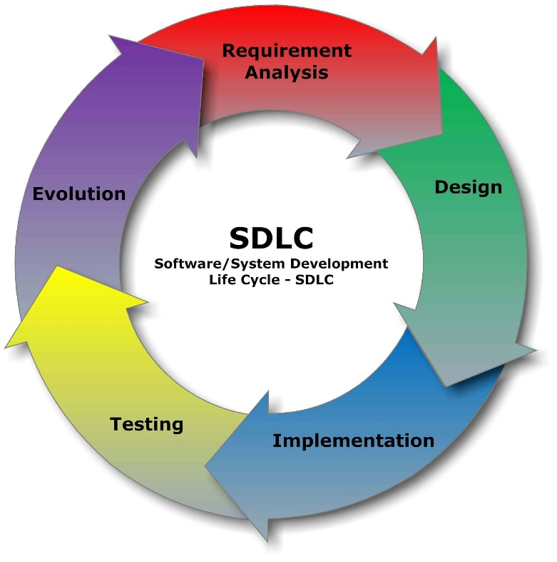

* ***Data Flow Diagram***

A data flow diagram (DFD) is a graphical representation of the “flow” of data through an information system, modeling its process aspects. Often they are a preliminary step used to create an overview of the system which can later be elaborated.

A DFD shows what kinds of data will be input to and output from the system, where the data will come from and go to, and where the data will be stored. It does not show information about the timing of processes, or information about whether processes will operate in sequence or in parallel (which is shown on a flowchart).

The DFD takes an input-process-output view of a system i.e. data objects flow into the software, are transformed by processing elements, and resultant data objects flow out of the software.

Data objects represented by labeled arrows and transformation are represented by circles also called as bubbles. DFD is presented in a hierarchical fashion i.e. the first data flow model represents the system as a whole. Subsequent DFD refine the context diagram (level 0 DFD), providing increasing details with each subsequent level.

DFD enables the software engineer to develop models of the information domain and functional domain at the same time. As the DFD is refined into greater levels of details, the analysts perform an implicit functional decomposition of the system. At the same time, the DFD refinement results in a corresponding refinement of the data as it moves through the process that embody the applications.

A context-level DFD for the system the primary external entities produce information for use by the system and consume information generated by the system. The labeled arrow represents data objects or object hierarchy.

Level 0:

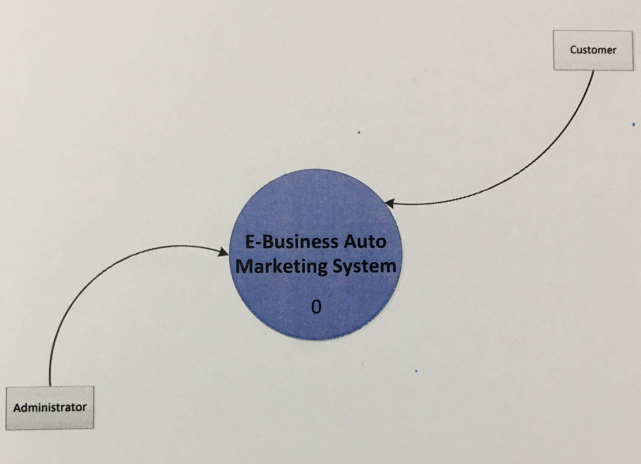

Level 1:

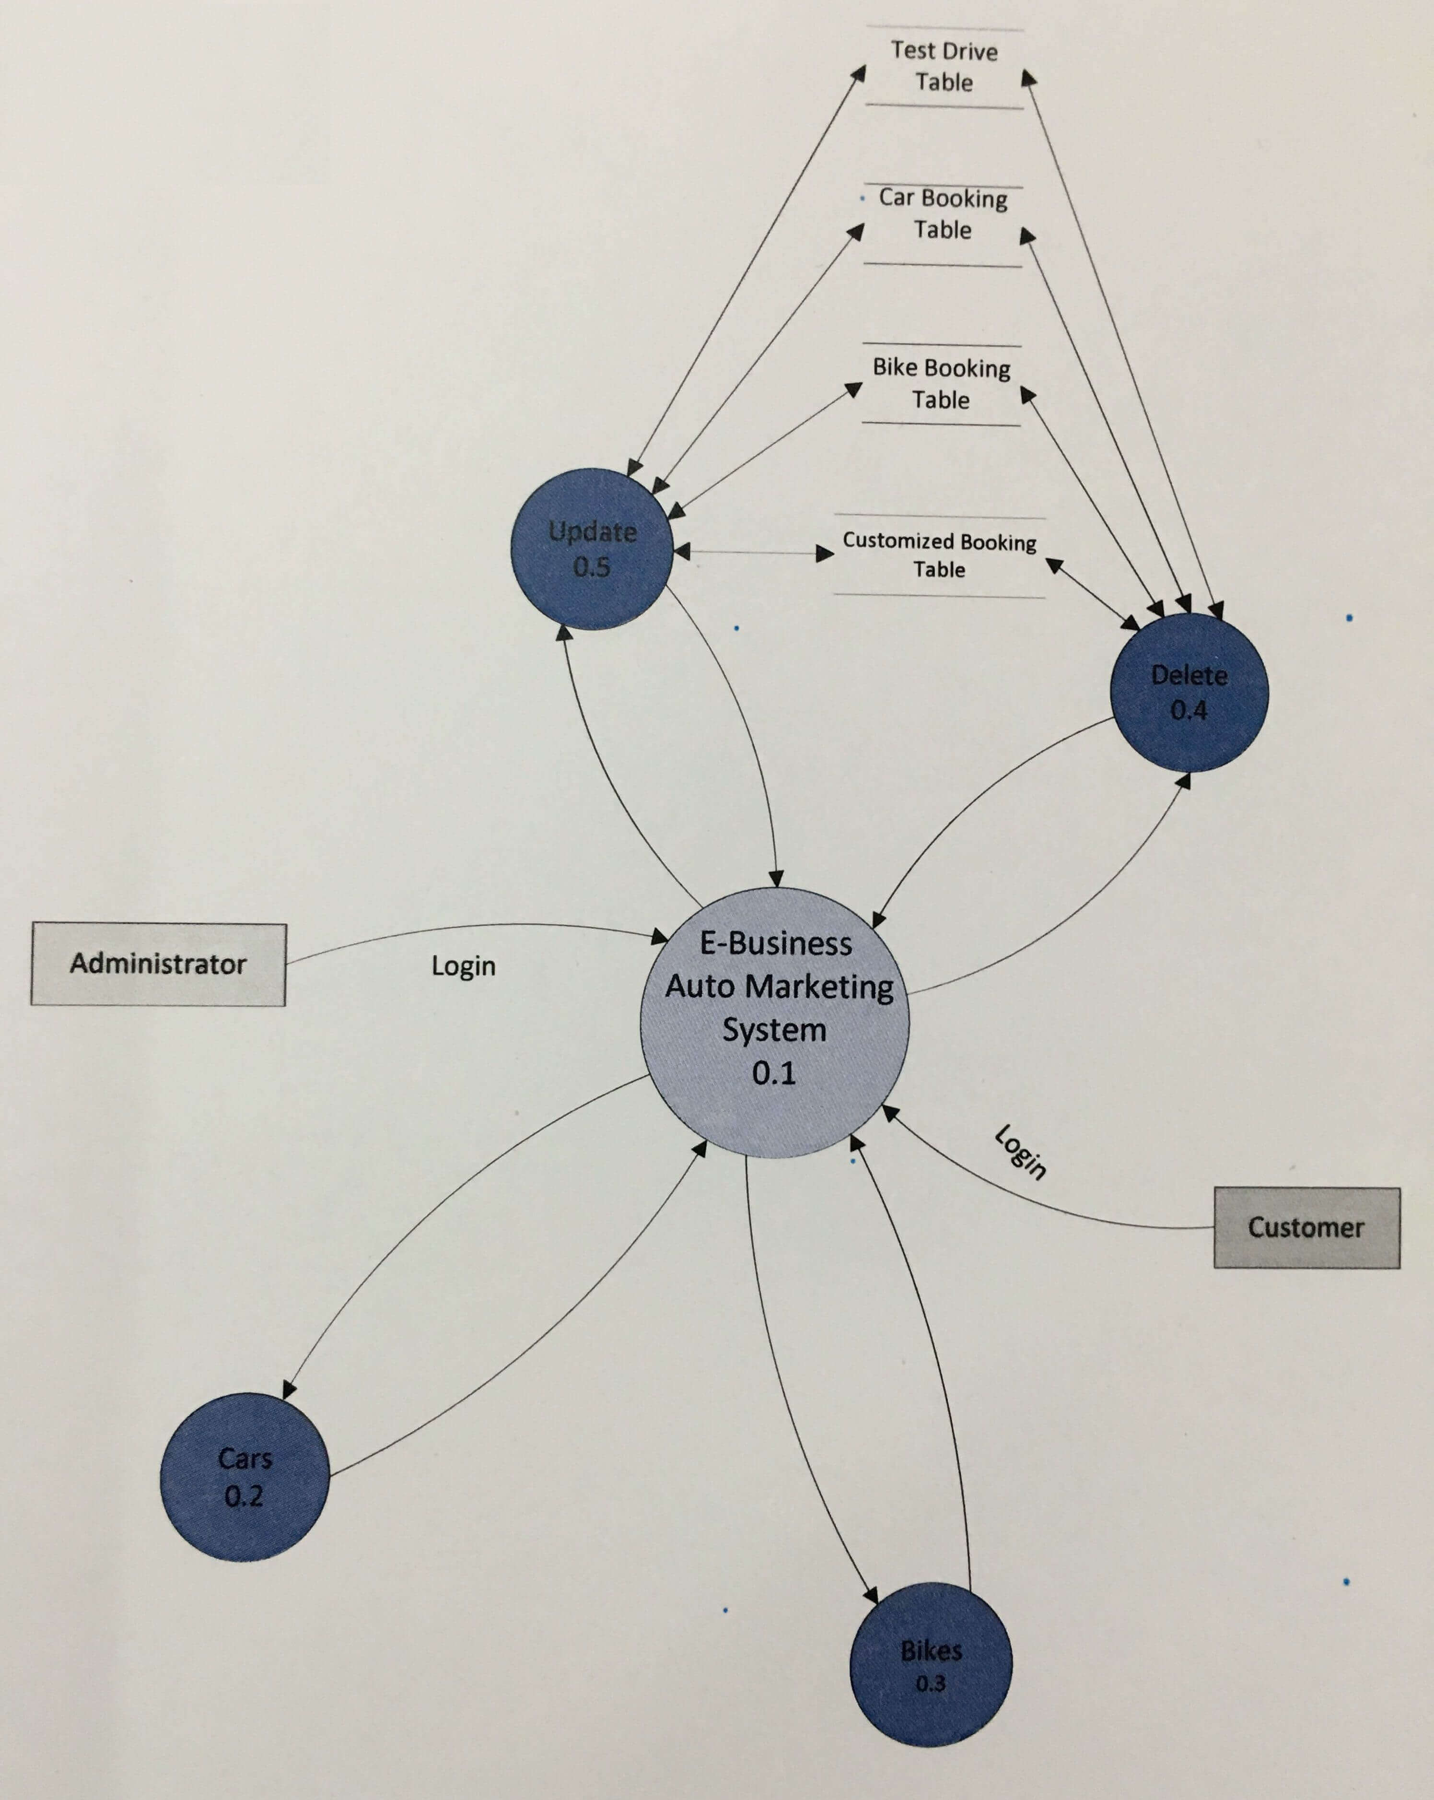

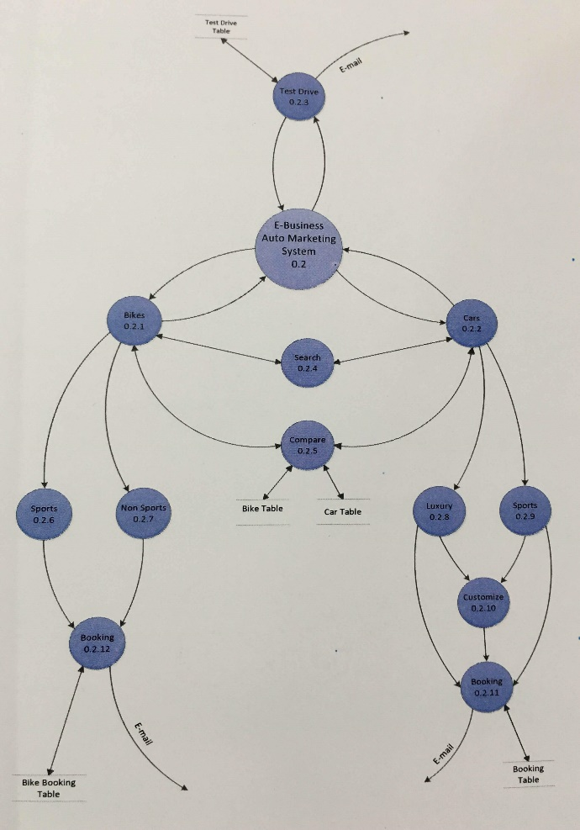Level 2:

* ***ER Diagram***

An entity relationship diagram is a data modeling technique that creates a graphical representation of the entities, and the relationships between entities, within an information system.

An entity may be defined as a thing which is recognized as being capable of an independent existence and which can be uniquely identified. An entity is an abstraction from the complexities of a domain. When we speak of an entity, we normally speak of some aspect of the real world which can be distinguished from other aspects of the real world.

An entity may be a physical object such as a house or a car, an event such as a house sale or a car service, or a concept such as a customer transaction or order. Although the term entity is the one most commonly used, following Chen we should really distinguish between an entity and an entity type. An entity type is a category. An entity, strictly speaking, is an instance of a given entity-type. There are usually many instances of an entity type. Because the term entity type is somewhat cumbersome, most people tend to use the term entity as a synonym for this term.

The steps involved in creating an ERD are:

1. Identify the entities
2. Determine all significant interactions
3. Analyze the nature of the interactions
4. Draw the ERD

ER-Diagram:

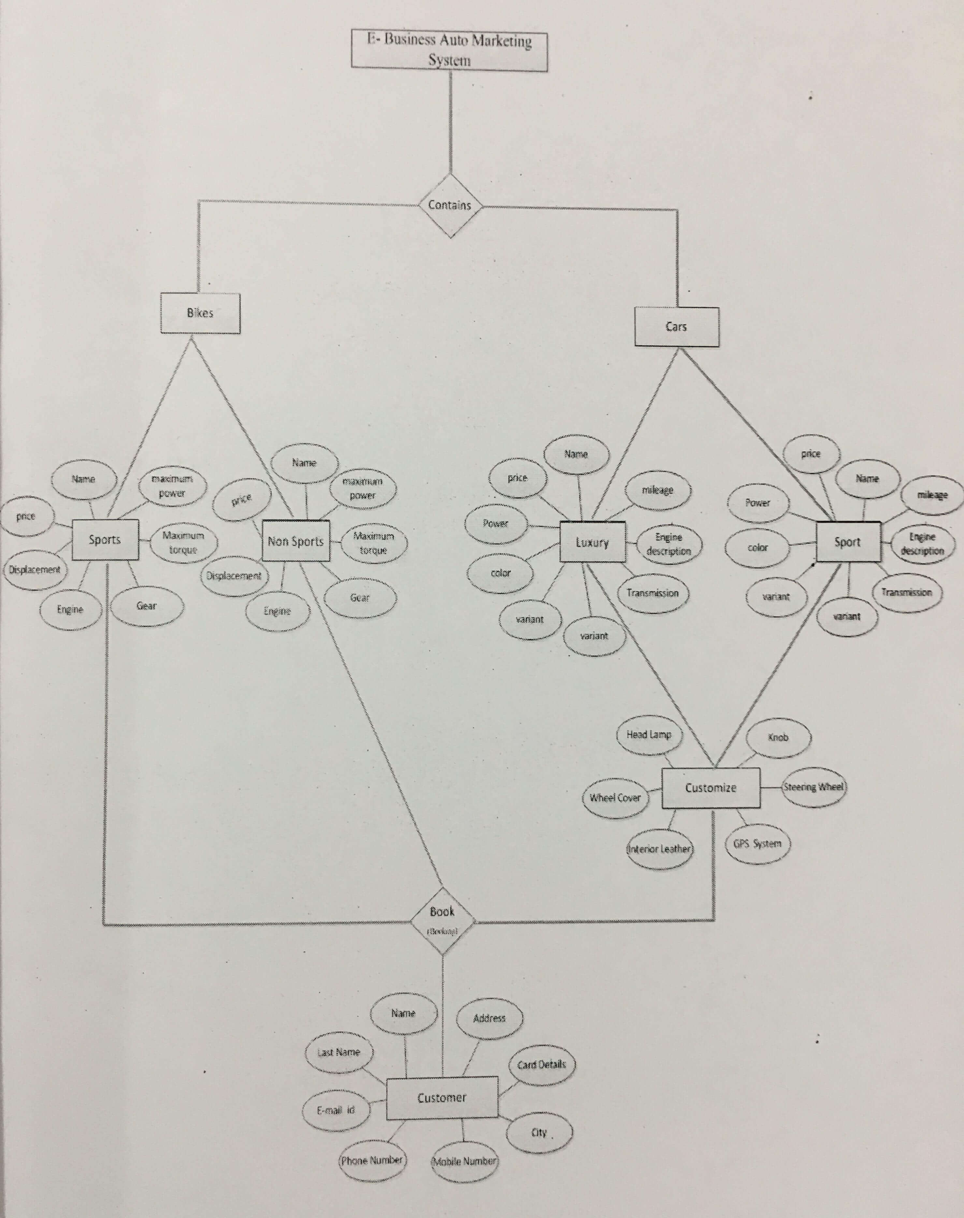

* ***Gantt Chart***

A Gantt chart is a horizontal bar chart developed as a production control tool in 1917 by Henry L. Gantt, an American engineer and social scientist. Frequently used in project management, a Gantt chart provides a graphical illustration of a schedule that helps to plan, coordinate, and track specific tasks in a project.

Gantt charts may be simple versions created on graph paper or more complex automated versions created using project management applications such as Microsoft Project or Excel.

A Gantt chart is constructed with a horizontal axis representing the total time span of the project, broken down into increments (for example days, weeks or months) and a vertical axis representing the tasks that make up the project.

A Gantt chart, commonly used in project management, is one of the most popular and useful ways of showing activities (tasks or events) displayed against time. Each activity is represented by a bar; the position and length of the bar reflects the start date, duration and end date of the activity. This allows you to see at a glance:

* What the various activities are?
* When each activity begins and ends.
* How long each activity is scheduled to last?
* Where activities overlap with other activities and how much?
* The start and end date of the whole project.

**Gantt chart**

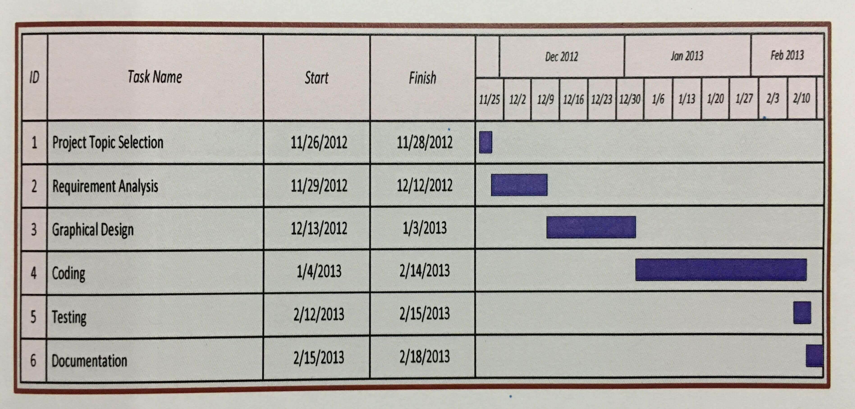

* ***State Transition***

The name of the diagram itself clarifies the purpose of the diagram and other details. It describes different states of a component in a system. The states are specific to a component/object of a system.

State transition diagrams have been used right from the beginning in object-oriented modeling. The basic idea is to define a machine that has a number of states (hence the term finite state machine). The machine receives events from the outside world and each event can cause the machine to transition from one state to another. For example, take a look at (figure 1), here the machine is a bottle in a bottling plant. It begins in the empty state. In that state it can receive squirt events. If the squirt event causes the bottle to become full, then it transitions to the full state, otherwise it says in the empty state (indicated by the transition back to its own state). When in the full state the cap event will cause it to transition to the sealed state. The diagram indicates that a full bottle does not receive squirt events, and that an empty bottle does not receive cap events. Thus you can get a good sense of what events should occur, and what effect they can have on the object.

State transition diagrams were around long before object modeling. They give an explicit, even a formal definition of behavior. A big disadvantage for them is that they mean that you have to define all the possible states of a system. Whilst this is all right for small systems, it soon breaks down in larger systems as there is an exponential growth in the number of states. This state explosion problem leads to state transition diagrams becoming far too complex for much practical use. To combat this state explosion problem, object-oriented methods define separate state transition diagrams for each class.

This pretty much eliminates the explosion problem since each class is simple enough to have a comprehensible state transition diagram. (It does however raise a problem in that it is difficult to visualize the behavior of the whole system from a number of diagrams of individual classes – which leads people to interaction and activity modeling).

**State Transition Diagram**

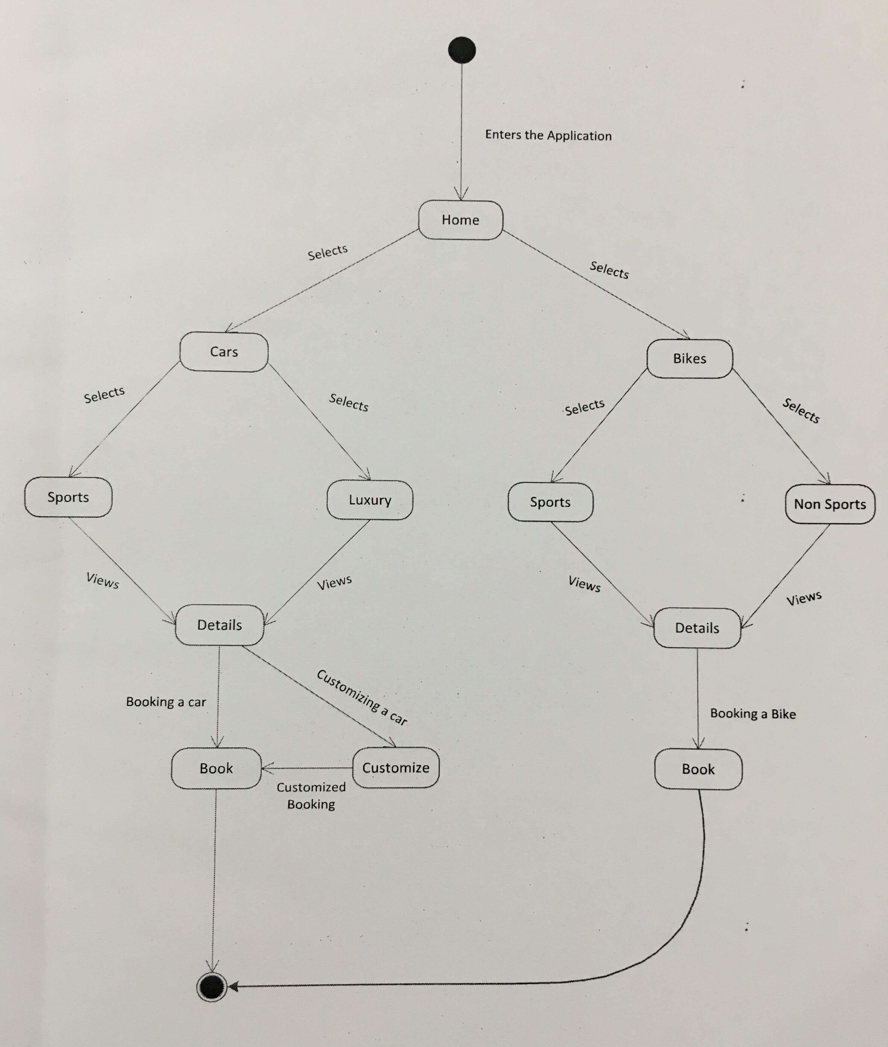

* ***Use Case***

A use case is a methodology used in system analysis to identify, clarify and organize system requirements. The use case is made up of a set of possible sequences of interactions between systems and users in a particular environment and related to a particular goal. It consists of a group of elements (for example classes and interfaces) that can be used to together in a way that will have an effect larger than the sum of the separate elements combined. The use case should contain all system activities that have significance to the users. A use case can be thought of as a collection of possible scenarios related to a particular goal, indeed the use case and goal are sometimes considered to be synonymous. The stick man represents what’s called an actor.

Use case diagram can be useful for getting an overall view of the system and clarifying who can do and more importantly what they can’t do. Use case diagram consists of use cases and actors and shows the interaction between the use case and actors.

The purpose is to show the interactions between the use case and actor. To represent the system requirements from users perspective. An actor could be the end-user of the system or an external system.

**Actor**:

A coherent set of roles that users of use cases play when interacting with the use cases.

**Use case**:

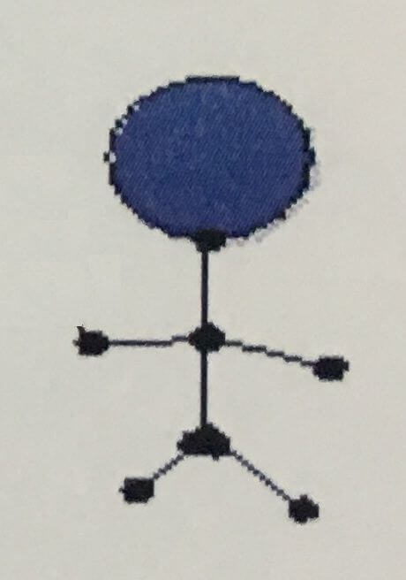

A description of sequence of actions, including variants, that a system performs that yields an observable result of value of an actor.

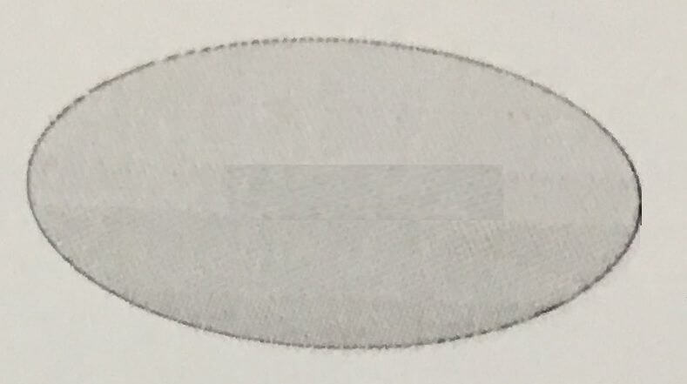

**UML Diagram**

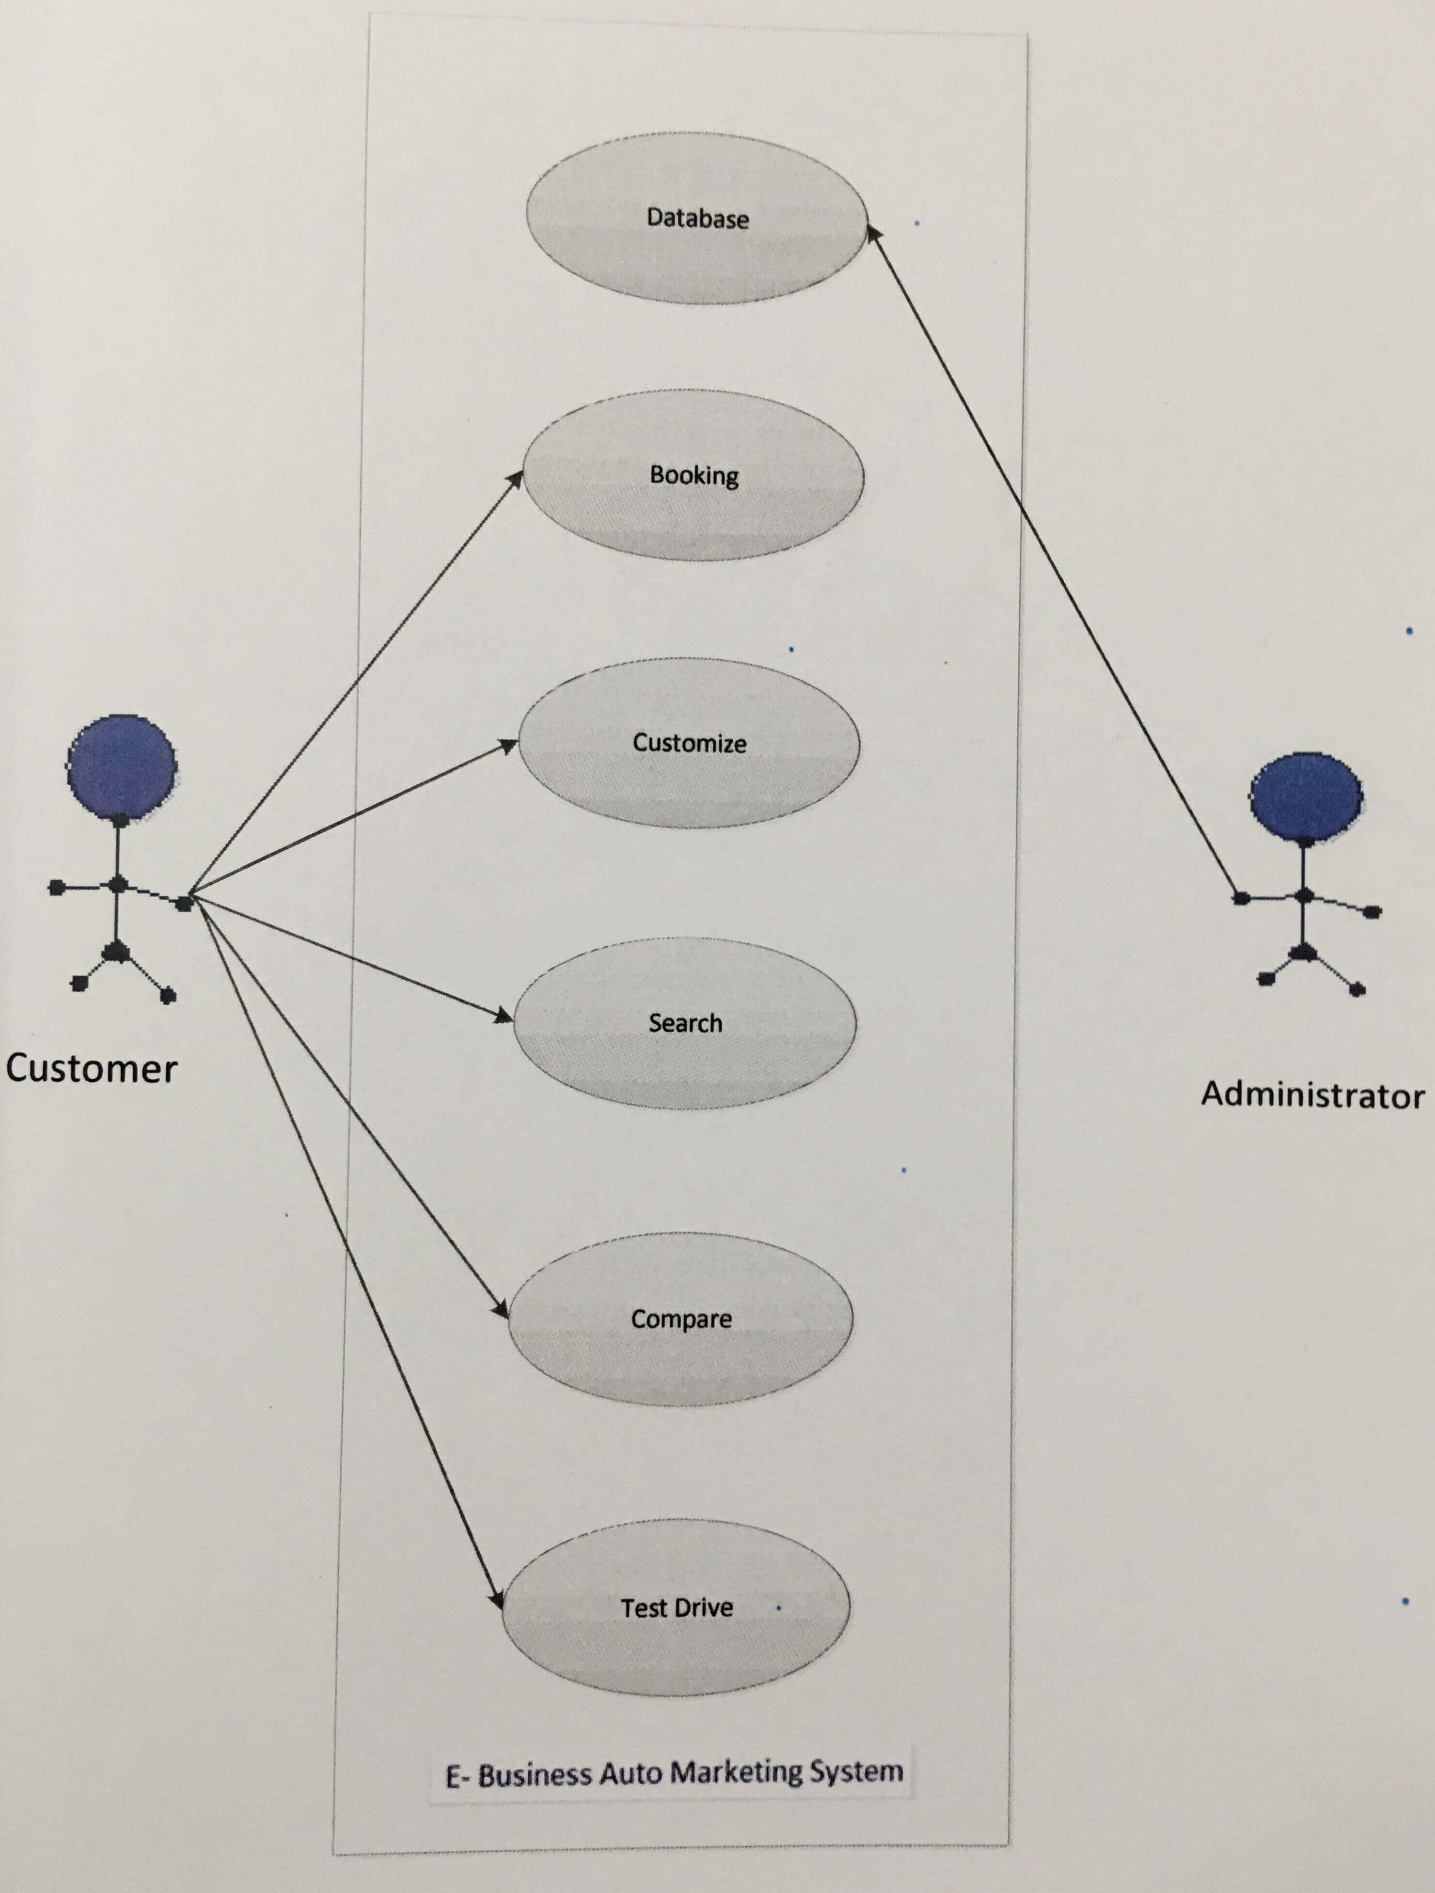

* ***PERT Chart***

A PERT chart is a graphic representation of a project’s schedule, showing the sequence of tasks, which tasks can be performed simultaneously and the critical path of tasks that must be completed on time in order for the project to meet its completion deadline.

The chart can be constructed with a variety of attributes, such as earliest and latest start dates for each task, earliest and latest finish dates for each task, and slack time between tasks. A PERT chart can document an entire project or a key phase of a project. The chart allows a team to avoid unrealistic timetables and schedule expectations, to help identify and shorten tasks that are bottlenecks, and to focus attention on most critical tasks.

PERT was developed primarily to simplify the planning and scheduling of large and complex projects.

It was developed for the US Navy Special Projects Office in 1957 to support the US Navy Polaris nuclear submarine project. It was able to incorporate uncertainty by making it possible to schedule a project while not knowing precisely the details and durations of all the activities. It is more of an event oriented technique rather than start and completion oriented and is used more in projects where time, rather than cost is the major factor. It is applied to very large scale, one time, complex, non-routine infrastructure and R&D projects.

**PERT Chart**

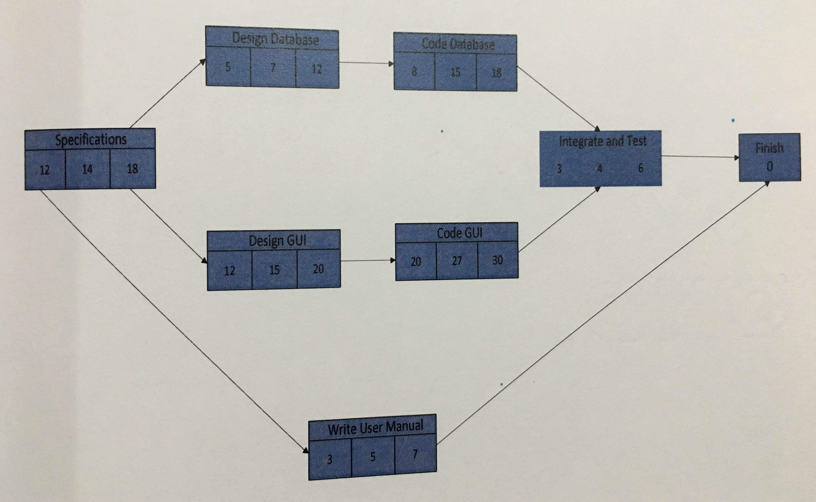

* ***Activity Diagram***

Activity diagram are graphical representation of workflows of stepwise activities and actions with support for choice, iteration and concurrency. In the Unified Modeling Language, activity diagrams can be used to describe the business and operational step-by-step workflows of components in a system. An activity diagram shows the overall flow of control.

**Activity Chart**

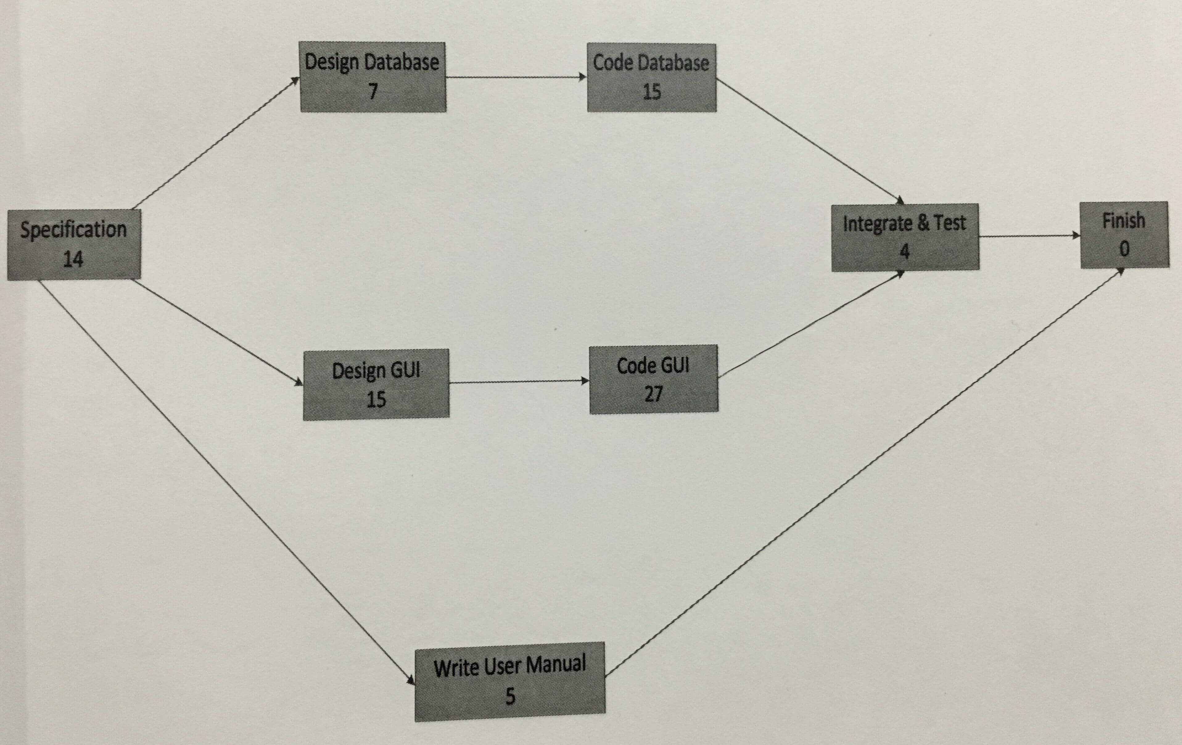

* ***Sequence Diagram***

A sequence diagram in a Unified Modeling language (UML) is a kind of interaction diagram that shows how processes operate with one another and in what order. It is construct of a Message Sequence Chart. A sequence diagram shows object interactions arranged in time sequence. It depicts the objects and classes involved in the scenario and the sequence of messages exchanged between the objects needed to carry out the functionality of the scenario. Sequence diagrams typically (but not always), are associated with use case realizations in the logical view of the system under development.

A sequence diagram shows, as parallel vertical lines (lifelines), different processes or objects that live simultaneously and as horizontal arrows, the messages exchanged between them, in the order in which they occur. This allows the specification of simple runtime scenarios in a graphical manner.

Sequence diagrams show the interaction between participating objects in a given use case. They are helpful to identify the missing objects that are not identified in the analysis object model. To see the interaction between objects, the following describe the sequence diagram of each identified use cases.

A sequence diagram can map a scenarios described by a use case in step by step detail to define how objects collaborate to achieve your applications goals.

A lifeline in a sequence diagram represents an object and shows all its points of interaction with other objects in events that are important to it. Lifelines start at the top of a sequence diagram and descend vertically to indicate the passage of time.

Interactions between objects messages and replies are drawn as horizontal direction arrows connecting lifelines. In addition, boxes known as combine fragments are drawn around sets of arrows to mark alternative actions, loops and other control structures.

**Sequence Diagram**

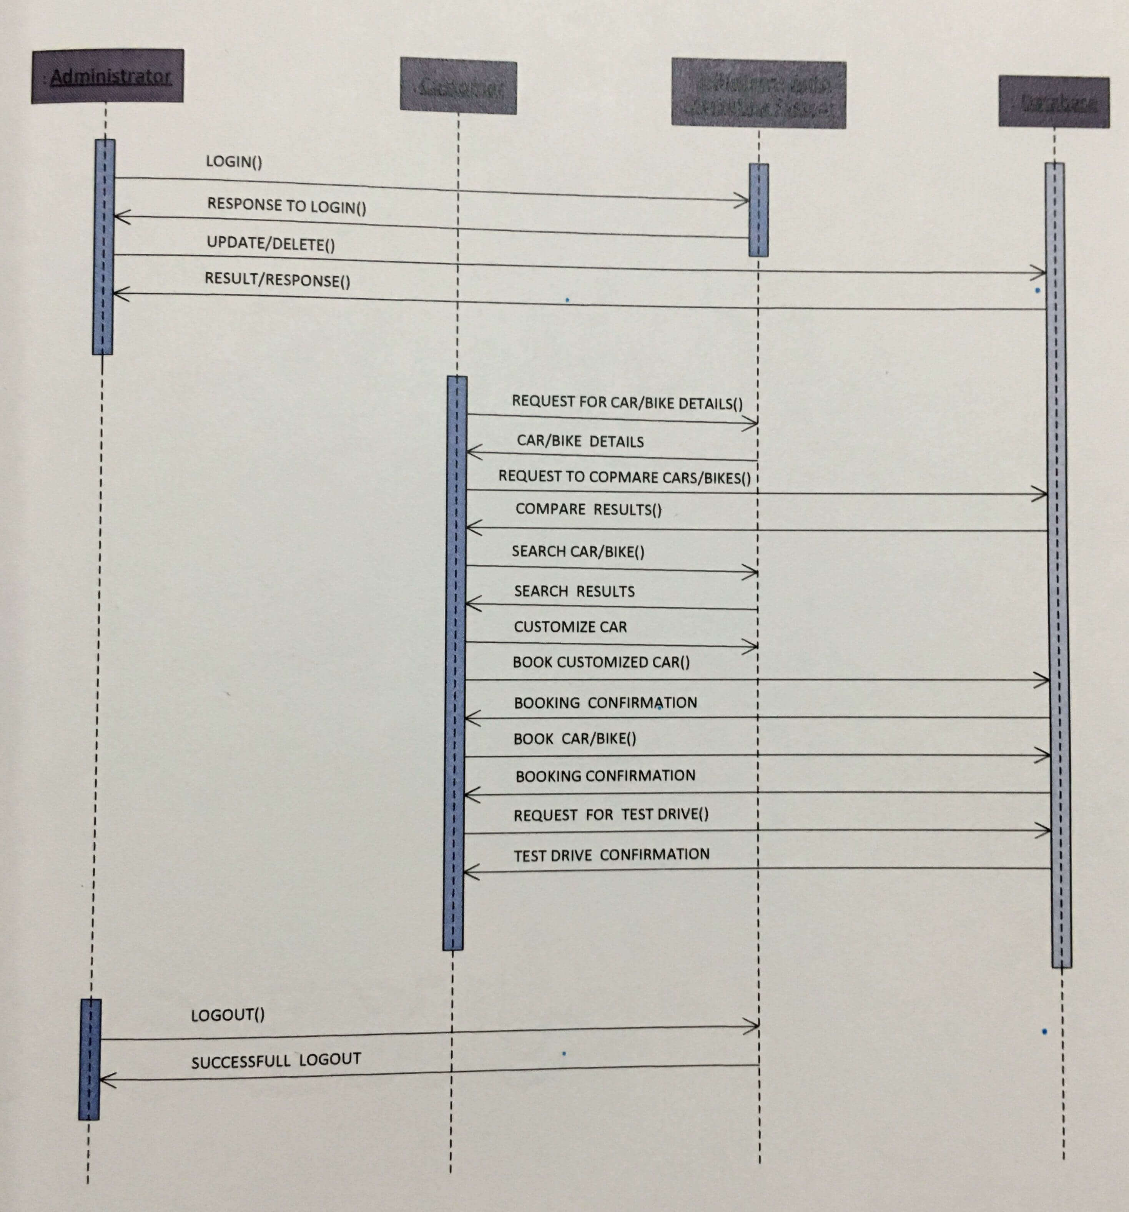

* ***Data Dictionary***

**Test drive**

|  |  |  |  |  |
| --- | --- | --- | --- | --- |
| Sr.no | Column Name | Datatype | Constraint | Description |
| 1 | CUST_NO | VARCHAR (20) | PRIMARY KEY | Unique ID of the customer. |
| 2 | CUST_NAME | VARCHAR (30) | NOT NULL | Name of the customer. |
| 3 | CUST_LASTNAME | VARCHAR (30) | NOT NULL | Last name of the customer. |
| 4 | CUST_EMAIL | VARCHAR (40) | NOT NULL | E-mail ID of the customer. |
| 5 | CUST_PHONENO | VARCHAR (20) | NOT NULL | Phone number of the customer. |
| 6 | VEHICLE_BRAND | VARCHAR (40) | NOT NULL | Name of the company |
| 7 | VEHICLE_MODEL | VARCHAR (40) | NOT NULL | Name of the model. |
| 8 | DAY_TIME | DATETIME | NOT NULL | Date and time of registration. |
| 9 | STATUS | VARCHAR (20) | NOT NULL | Status of the registration |

**Bike Booking**

|  |  |  |  |  |
| --- | --- | --- | --- | --- |
| Sr.no | Column Name | Datatype | Constraint | Description |
| 1 | CUST_NO | VARCHAR (20) | PRIMARY KEY | Unique ID of the customer. |
| 2 | CUST_NAME | VARCHAR (30) | NOT NULL | Name of the customer. |
| 3 | CUST_LASTNAME | VARCHAR (30) | NOT NULL | Last name of the customer. |
| 4 | CUST_ADDRESS | VARCHAR (50) | NOT NULL | Address of the customer. |
| 5 | CUST_PHONENO | VARCHAR (20) | NOT NULL | Phone number of the customer. |
| 6 | CUST_MOBILENO | VARCHAR (20) | NOT NULL | Mobile number of the customer. |
| 7 | CUST_EMAIL | VARCHAR (40) | NOT NULL | E-mail ID of the customer. |
| 8 | BIKE_COMPANY | VARCHAR (40) | NOT NULL | Name of the company. |
| 9 | BIKE_NAME | VARCHAR (40) | NOT NULL | Name of the model. |
| 10 | CARD_TYPE | VARCHAR(20) | NOT NULL | Type of card. |
| 11 | CARD_NO | VARCHAR (40) | NOT NULL | Number of the card. |
| 12 | AMOUNT | MONEY | DEFAULT VALUE (Rs 10,000) | The amount for booking. |
| 13 | CITY | VARCHAR (20) | NULL | City of the customer. |
| 14 | DAY_TIME | DATETIME | NOT NULL | Date and time of registration. |
| 15 | STATUS | VARCHAR (20) | NOT NULL | Status of the registration. |

**Car Booking**

|  |  |  |  |  |
| --- | --- | --- | --- | --- |
| Sr.no | Column Name | Datatype | Constraint | Description |
| 1 | CUST_NO | VARCHAR (20) | PRIMARY KEY | Unique ID of the customer. |
| 2 | CUST_NAME | VARCHAR (30) | NOT NULL | Name of the customer. |
| 3 | CUST_LASTNAME | VARCHAR (30) | NOT NULL | Last name of the customer. |
| 4 | CUST_ADDRESS | VARCHAR (50) | NOT NULL | Address of the customer. |
| 5 | CUST_PHONENO | VARCHAR (20) | NOT NULL | Phone number of the customer. |
| 6 | CUST_MOBILENO | VARCHAR (20) | NOT NULL | Mobile number of the customer. |
| 7 | CUST_EMAIL | VARCHAR (40) | NOT NULL | E-mail ID of the customer. |
| 8 | CAR_COMPANY | VARCHAR (40) | NOT NULL | Name of the company. |
| 9 | CAR_NAME | VARCHAR (40) | NOT NULL | Name of the model. |
| 10 | CARD_TYPE | VARCHAR(20) | NOT NULL | Type of card. |
| 11 | CARD_NO | VARCHAR (40) | NOT NULL | Number of the card. |
| 12 | AMOUNT | MONEY | DEFAULT VALUE (Rs 10,000) | The amount for booking. |
| 13 | CITY | VARCHAR (20) | NULL | City of the customer. |
| 14 | DAY_TIME | DATETIME | NOT NULL | Date and time of registration. |
| 15 | STATUS | VARCHAR (20) | NOT NULL | Status of the registration. |

**Customized Car Booking**

|  |  |  |  |  |
| --- | --- | --- | --- | --- |
| Sr.no | Column Name | Datatype | Constraint | Description |
| 1 | CUST_NO | VARCHAR (20) | PRIMARY KEY | Unique ID of the customer. |
| 2 | CUST_NAME | VARCHAR (30) | NOT NULL | Name of the customer. |
| 3 | CUST_LASTNAME | VARCHAR (30) | NOT NULL | Last name of the customer. |
| 4 | CUST_ADDRESS | VARCHAR (50) | NOT NULL | Address of the customer. |
| 5 | CUST_PHONENO | VARCHAR (20) | NOT NULL | Phone number of the customer. |
| 6 | CUST_MOBILENO | VARCHAR (20) | NOT NULL | Mobile number of the customer. |
| 7 | CUST_EMAIL | VARCHAR (40) | NOT NULL | E-mail ID of the customer. |
| 8 | CAR_COMPANY | VARCHAR (40) | NOT NULL | Name of the company. |
| 9 | CAR_NAME | VARCHAR (40) | NOT NULL | Name of the model. |
| 10 | KNOB | VARCHAR (20) | NOT NULL | Car knob selected by customer. |
| 11 | STEERING_WHEEL | VARCHAR (20) | NOT NULL | Steering wheel selected by customer. |
| 12 | HEAD_LAMP | VARCHAR (20) | NOT NULL | Head lamps selected by customer. |
| 13 | WHEEL_COVER | VARCHAR (20) | NOT NULL | Wheel cover selected by customer. |
| 14 | GPS_SYSTEM | VARCHAR (20) | NOT NULL | GPS system selected by customer. |
| 15 | INTERIOR_LEATHER | VARCHAR (20) | NOT NULL | Interior leather selected by customer. |
| 16 | CARD_TYPE | VARCHAR(20) | NOT NULL | Type of card. |
| 17 | CARD_NO | VARCHAR (40) | NOT NULL | Number of the card. |
| 18 | AMOUNT | MONEY | DEFAULT VALUE (Rs 10,000) | The amount for booking. |
| 19 | CITY | VARCHAR (20) | NULL | City of the customer. |
| 20 | DAY_TIME | DATETIME | NOT NULL | Date and time of registration. |
| 21 | STATUS | VARCHAR (20) | NOT NULL | Status of the registration. |

**Car Compare**

|  |  |  |  |  |
| --- | --- | --- | --- | --- |
| Sr.no | Column Name | Datatype | Constraint | Description |
| 1 | NAME | VARCHAR (40) | PRIMARY KEY | Name of car. |
| 2 | PRICE | VARCHAR (40) | NOT NULL | Price of car. |
| 3 | PHOTO | IMAGE | NOT NULL | Image of car. |
| 4 | VARIANT1 | VARCHAR (30) | NOT NULL | Variant of the car. |
| 5 | VARIANT2 | VARCHAR (30) | NOT NULL | Other variant of the car. |
| 6 | VARIANT3 | VARCHAR (30) | NOT NULL | Other variant of the car. |
| 7 | TRANSMISSION1 | VARCHAR (30) | NOT NULL | Transmission of car. |
| 8 | TRANSMISSION2 | VARCHAR (30) | NOT NULL | Transmission of other variant. |
| 9 | TRANSMISSION3 | VARCHAR (30) | NOT NULL | Transmission of other variant |
| 10 | ENGINEDESCRIPTION1 | VARCHAR (60) | NOT NULL | Engine description of the car. |
| 11 | ENGINEDESCRIPTION2 | VARCHAR (60) | NOT NULL | Engine description of other variant of the car. |
| 12 | ENGINEDESCRIPTION3 | VARCHAR (60) | NOT NULL | Engine description of the other variant of car. |
| 13 | MILEAGE1 | VARCHAR (30) | NOT NULL | Mileage of car. |
| 14 | MILEAGE2 | VARCHAR (30) | NULL | Mileage of other variant of the car. |
| 15 | MILEAGE3 | VARCHAR (30) | NULL | Mileage of other variant. |
| 16 | AC1 | VARCHAR(30) | NOT NULL | Air conditioner for the car. |
| 17 | AC2 | VARCHAR (30) | NULL | Air conditioner for other variant. |
| 18 | AC3 | VARCHAR (30) | NULL | Air conditioner for car. |
| 19 | POWERSTEERING1 | VARCHAR (30) | NOT NULL | Power steering of the car. |
| 20 | POWERSTEERING2 | VARCHAR (30) | NULL | Power steering for car. |
| 21 | POWERSTEERING3 | VARCHAR (30) | NULL | Power steering for car. |
| 22 | CENTRALLOCKING1 | VARCHAR (30) | NOT NULL | Central locking for car. |
| 23 | CENTRALLOCKING2 | VARCHAR (30) | NULL | Central locking for car. |
| 24 | CENTRALLOCKING3 | CARCHAR (30) | NULL | Central locking for car. |

**Bike Compare**

|  |  |  |  |  |
| --- | --- | --- | --- | --- |
| Sr.no | Column Name | Datatype | Constraint | Description |
| 1 | NAME | VARCHAR (40) | PRIMARY KEY | Name of bike. |
| 2 | PRICE | MONEY | NOT NULL | Price of bike. |
| 3 | PHOTO | IMAGE | NOT NULL | Image of bike. |
| 4 | DISPLACEMENT | VARCHAR (10) | NOT NULL | Displacement of the bike. |
| 5 | ENGINE | VARCHAR (30) | NOT NULL | Engine specifications of the bike |
| 6 | MAXIMUM_POWER | VARCHAR (40) | NOT NULL | Maximum power of the bike. |
| 7 | MAXIMUM TORQUE | VARCHAR (40) | NOT NULL | Maximum torque of the bike. |
| 8 | GEAR | VARCHAR (30) | NOT NULL | Gears available for the bike. |

**Bank**

|  |  |  |  |  |
| --- | --- | --- | --- | --- |
| Sr.no | Column Name | Datatype | Constraint | Description |
| 1 | NAME | VARCHAR (30) | NOT NULL | Name of bank account holder. |
| 2 | CARD_NO | VARCHAR (50) | NOT NULL | Credit/debit card number of the account holder. |
| 3 | COMMENT | NTEXT | NULL | Comment or queries posted by customer. |

***System Implementation***

Implementation is the stage in the project where the theoretical design is turned into a working system. The most crucial stage is achieving a successful new system and giving the user confidence in that the new system will work efficiently and effectively in the implementation state.

The stage consist of:

1. Testing the developed program with simple data
2. Detection and correction of error.
3. Creating whether the system meets user requirements.
4. Testing whether the system
5. Making necessary changes as desired by the user.
6. Training user personnel.

**Implementation Procedures:**

The implementation phase is less creative than system design. A system project may be dropped at any time prior to implementation, although it becomes more difficult when it goes to the design phase.

The final report to the implementation phase includes procedural flowcharts, record layouts, report layouts and a workable plan for implementing the candidate system design into an operational one. Conversion is one aspect of implementation.

**Several procedures of documents are unique to the conversion phase. They include the following:**

1. The conversion portion of the implementation plan is finalized and approved.
2. Files are converted.
3. Parallel processing between the existing and the new system are logged on a special form.
4. Assuming no problems, parallel processing is discontinued. Implementation results are documented for reference.

**Operational Documentation:**

Documentation means of communication; it establishes design and performance criteria for phases of the project. Documentation is descriptive information that portrays the use and / or operation of the system.

* Documentation tools:

Document production and desktop publishing tool support nearly every aspect of software developers. Most software development organizations spend a substantial amount of time developing documents, and in many cases the documentation process itself is quite inefficient. It is not use unusual for a software development effort on documentation. For this reason, documentation tools provide an important opportunity to improve productivity.

* Document Restructuring:

Creating document is time consuming. If the system works, we’ll live with what we have. In some cases, this is correct approach. It is not possible to recreate document for hundreds of computer programs. Documentation must be updated, but we have limited resources. It may not be necessary to fully re-document an application. Rather, those portions of the system that are currently undergoing change are fully documented. The system is business critical and must be fully re-documented. Even in this case, an intelligent approach is to pare documentation to an essential minimum.

***Testing***

Software testing is a critical element of software quality assurance and represents the ultimate review of specification, design and coding. The increasing visibility of software as a system element and attendant costs associated with a software failure are motivating factors for we planned, through testing. Testing is the process of executing a program with the intent of finding an error. The design of tests for software and other engineered products can be as challenging as the initial design of the product itself.

There are basically two types of testing approaches:

* Black box testing
* White box testing

**Black box testing:**

The specified function that a product has been designed to perform, tests can be conducted that demonstrate each function is fully operated.

**White box testing:**

Knowing the internal workings of the product, tests can be conducted to ensure that the internal operation of the product performs according to specifications and all internal components have been adequately exercised.

White box and black box testing methods have been used to test this package. All the loop constructs have been tested for their boundary and intermediate conditions.

The test data was designed with a view to check for all the conditions and logical decisions. Error handling has been taken care of by the use of exception handlers.

**Testing Strategies:**

Testing is a set of activities that can be planned in advanced and conducted systematically. A strategy for software testing must accommodate low level tests that are necessary to verify that a small source code segment has been correctly implemented as well as high level tests that validate major system functions against customer requirements.

Software testing is one element of verification and validation. Verification refers to the set of activities that ensure that software correctly implements as specific function. Validation refers to a different set of activities that ensure that the software that has been built is traceable to customer requirements.

The objective of software testing is to uncover errors. To fulfill this objective, a series of test steps unit, integration, validation and system tests are planned and executed. Each test step is accomplished through a series of systematic test technique that assist in the design of test cases. With each testing step, the level of abstraction with which software is considered is broadened.

* **Unit Testing:**

Unit testing focuses verification effort on the smallest unit of software design – the module. The unit test is always white box oriented. The tests that occur as part of unit testing are testing the module interface, examining the local data structures, testing the boundary conditions, executing all the independent paths and testing error-handling paths.

* **Integration Testing:**

Integration testing is a systematic technique for constructing the program structure while at the same time conducting tests to uncover errors associated with interfacing. Scope of testing summarizes the specific functional, performance and internal design characteristics that are to be tested. It employs top-down testing and bottom-up testing methods for this case.

* **System Testing:**

System testing validates software once it has been incorporated into a larger system. Software is incorporated with other system elements and a series of system integration and validation tests are conducted. System testing is actually a series of different test whose primary purpose is to fully exercise the computer based system.

Once the system has been developed it has to be tested. In the present system we have to take care of valid property and assessment numbers i.e. there should not exists any duplicate number in each case. Care should be taken that the appropriate data is retrieved in response to the queries.

* **Validation:**

The terms verification and validations are used interchangeably, we will describe both these methods. Verification is the process of determining whether or not the products of given phase of software development fulfill the specifications established in the previous phase. These activities include proving and reviews.

Validation is the process of evaluating the software at the end of software development process, we find how well the software satisfies the requirements specifications. The requirement of the software starts with requirement document and requirement specifications with errors and specifying client’s requirements correctly.

The validation process of evaluating the developed system at the end is to ensure that it must satisfy all the necessary requirement specification. Requirement verification also checks the factors as completeness, consistency and testability of the requirements.

***Maintenance***

Maintenance is actually the implementation of the review plan. As important as it is, many programmers and analysts are to perform or identify themselves with the maintenance effort. There are psychological, personality and professional reasons for this. Analysts and programmers spend far more time maintaining programs than they do writing them. Maintenance accounts for 50-80 percent of total system development.

An integral part of software is the maintenance one, which requires an accurate maintenance plan to be prepared during the software development. It should specify how users will request modifications or report problems. The software maintenance, can last for 5-6 years (or even decades) after the development process, calls for an effective plan which can address the scope of software maintenance, the tailoring of the post-delivery / deployment process, the designation of who will provide maintenance, and an estimate of the lifecycle costs. Software maintenance is classified into corrective, adaptive, perfective and preventive maintenance. In this project focus is towards corrective maintenance to overcome all the problems arising in requirements, design, coding, and documentation and testing activities.

* Adaptive changes… made in order to become suited to different conditions.
* Corrective changes… made in order to remove defects.
* Perfective changes… made in order to improve the software.
* Preventive changes… made in order to reverse deterioration.

Defects (bugs) result from: design error; logic errors; coding errors

1. Database Design and Implementation

The design of the database was similar to the analysis phase. The database has been developed using SQL Server 2008. These are the main tables in the application and others are lookup and query tables. The tables were derived from the ER-Diagram.

1. User Interface Design and Implementation

The user interface of the application has been designed using Microsoft Visual Studio 2010. The main controls used in the design are Repeaters, Ajax Update Panel, Ajax Toolkit controls textbox and Auto complete controls.

The aim is to collect the data against which this application can be examined for issues of quality. This includes:

* Checking for broken links.
* Checking for missing content e.g. images.
* Checking for data loss.
* Checking the spelling and grammar of content.
* Checking for data redundancy and data retrieval.
* Checking that applications are functioning correctly.
* Checking that legal and regulatory guidelines are being adhered to e.g. data protection and privacy.
* Checking that application matches to the organizations requirement.
* Checking that the application design standard is maintained according to the organization.

***Software Snapshot***

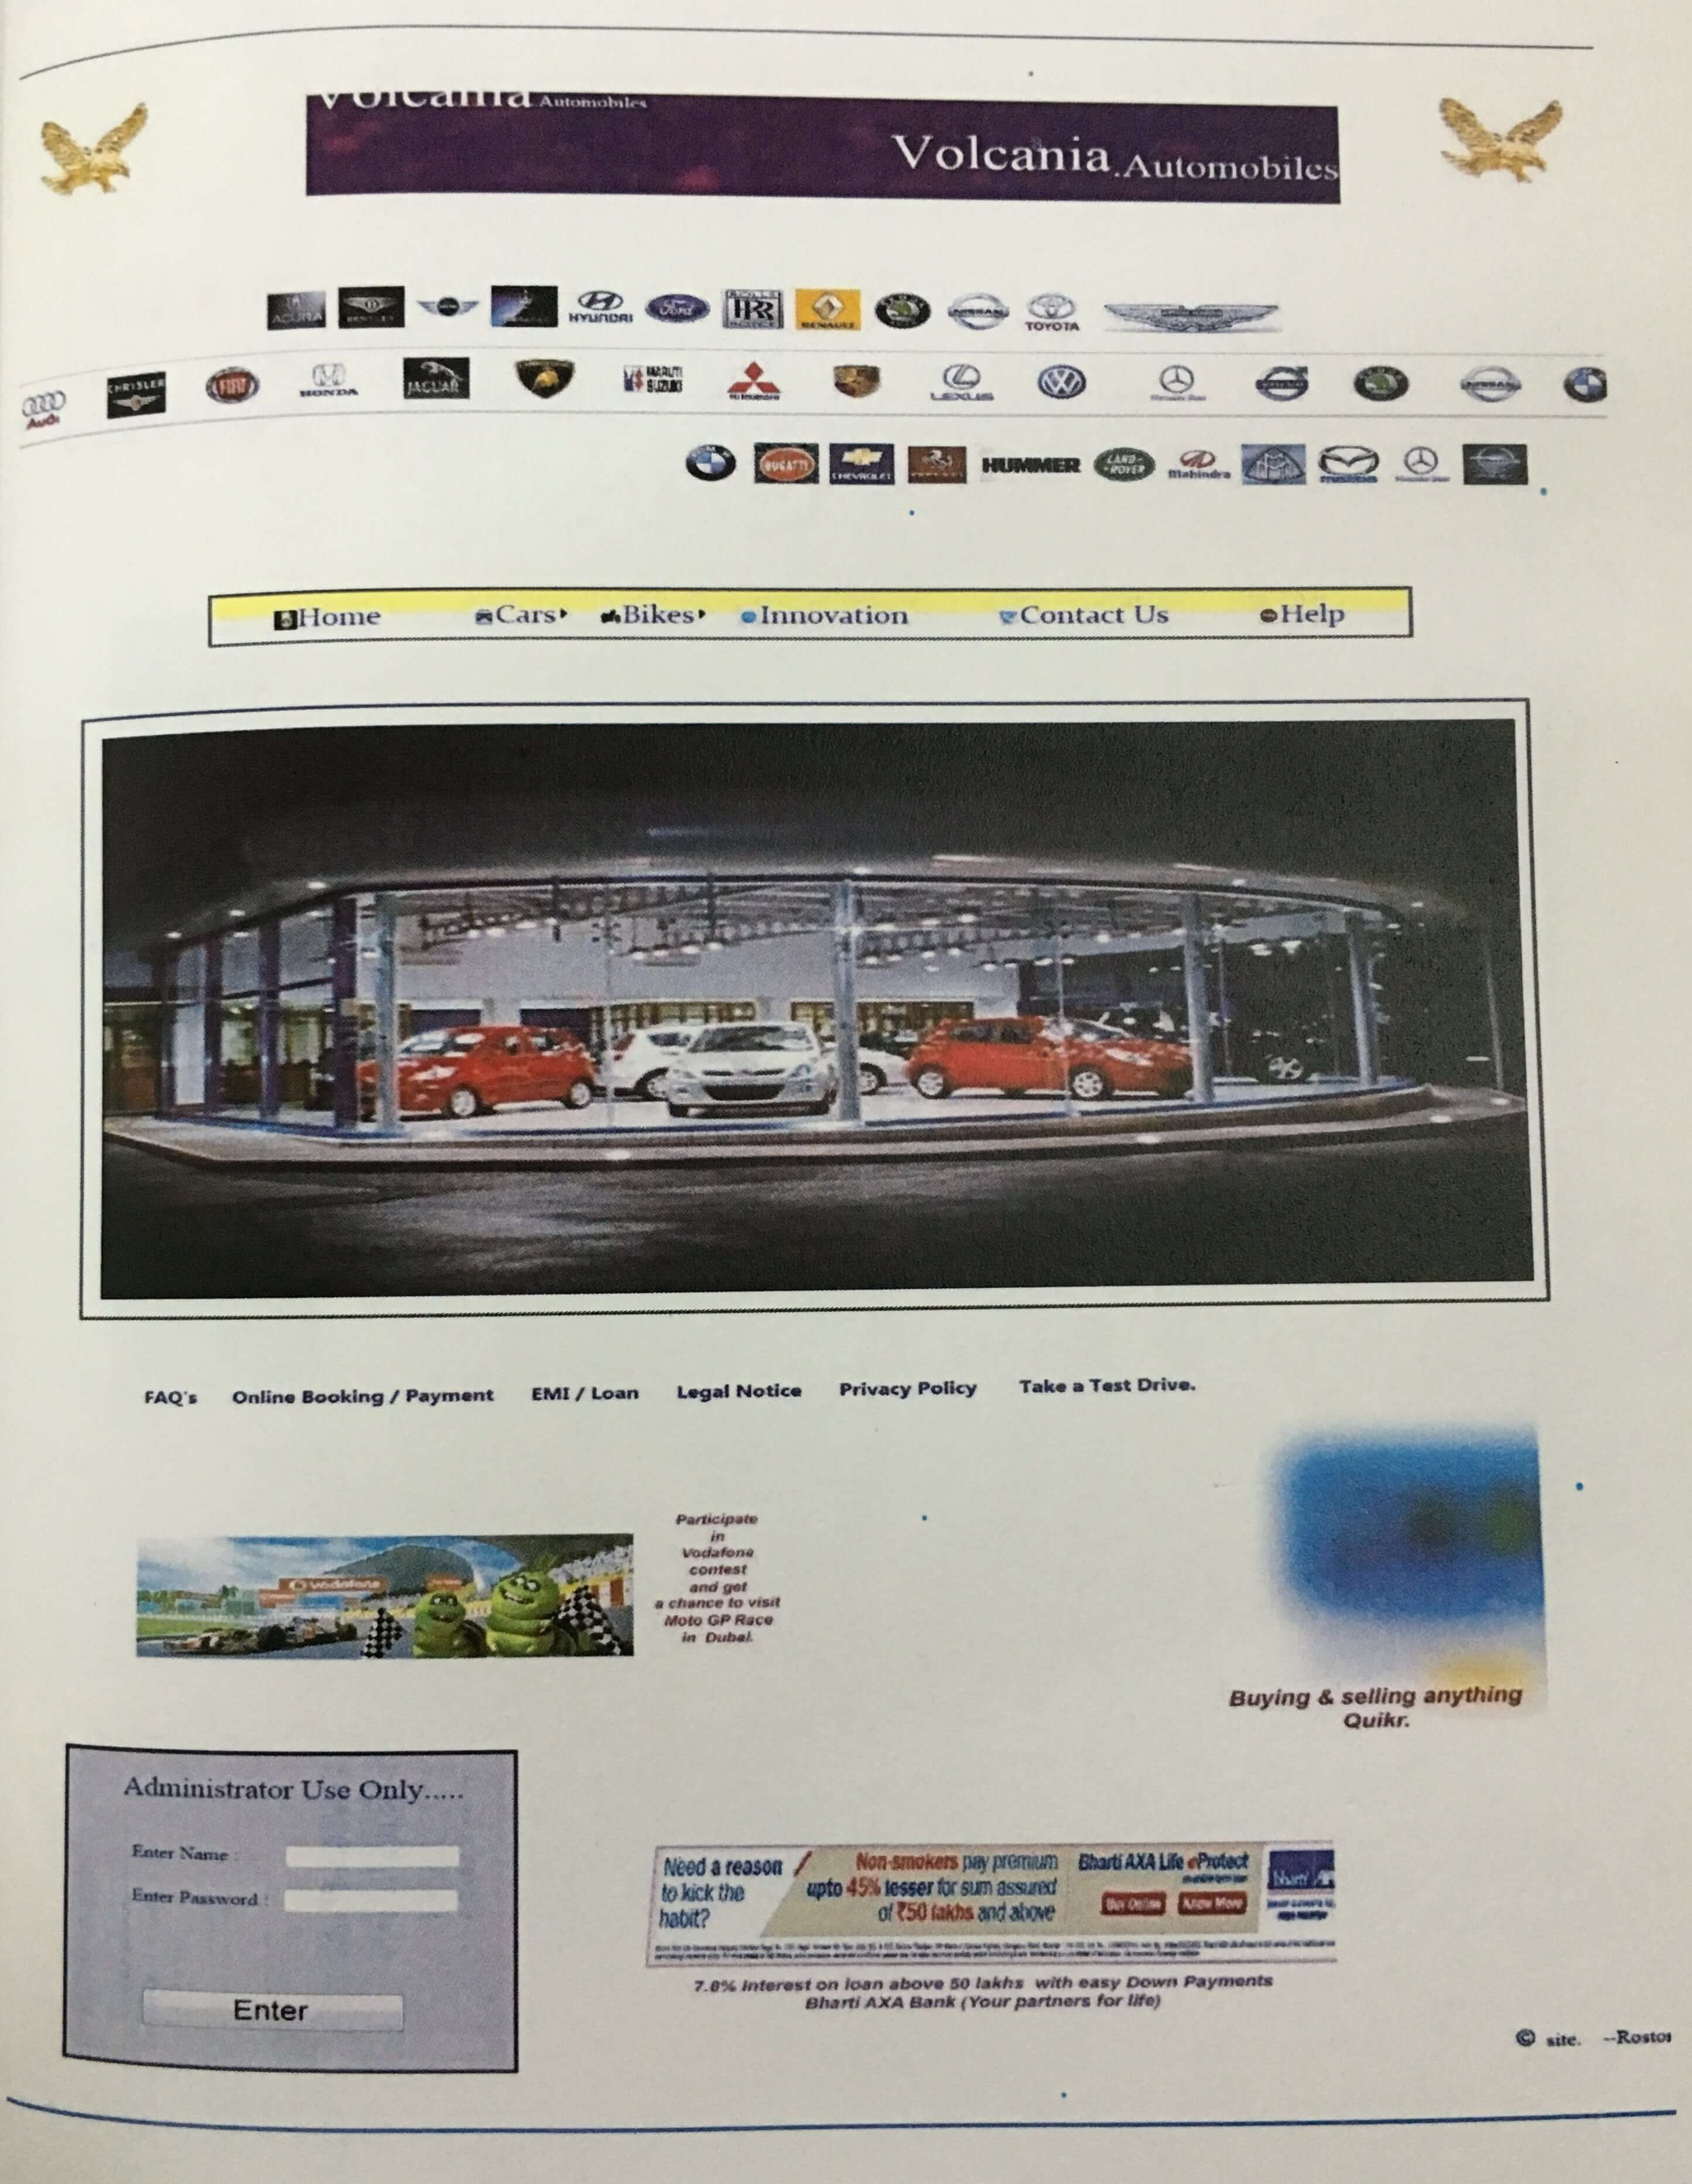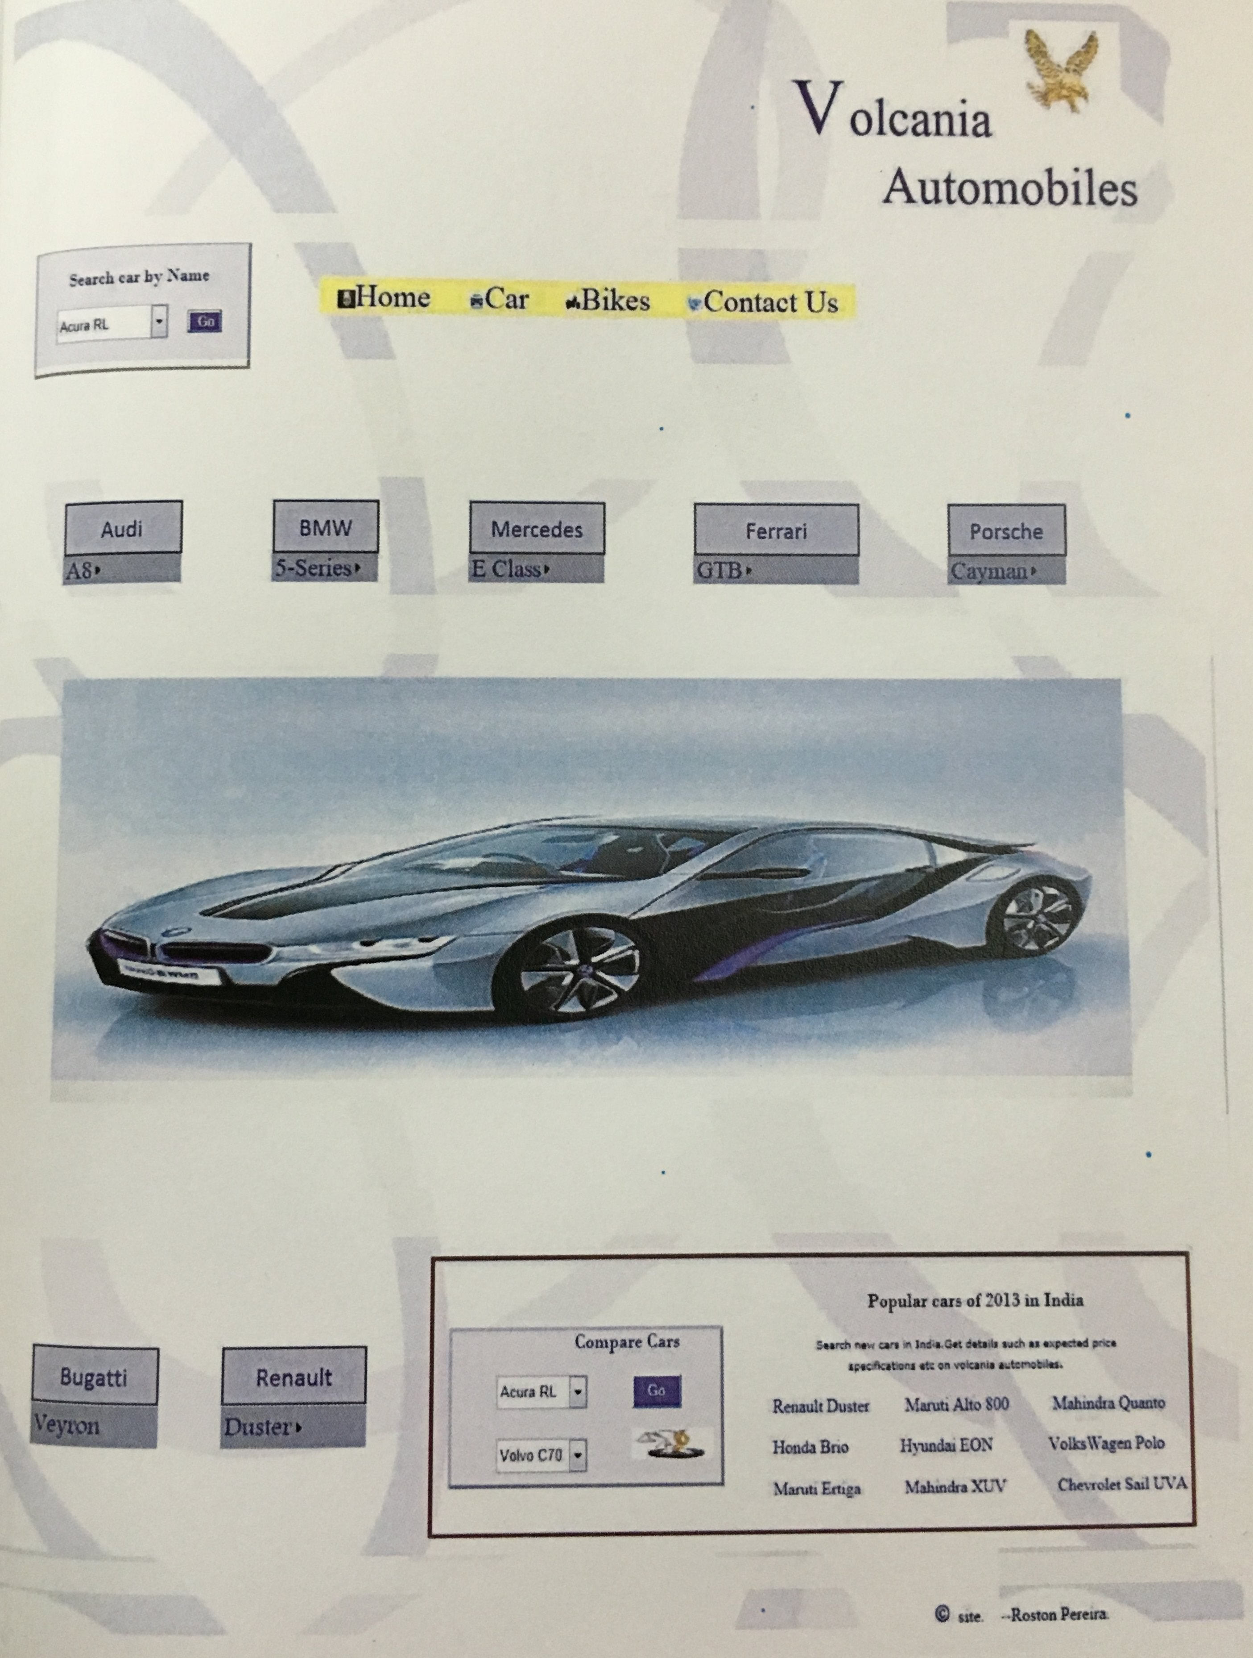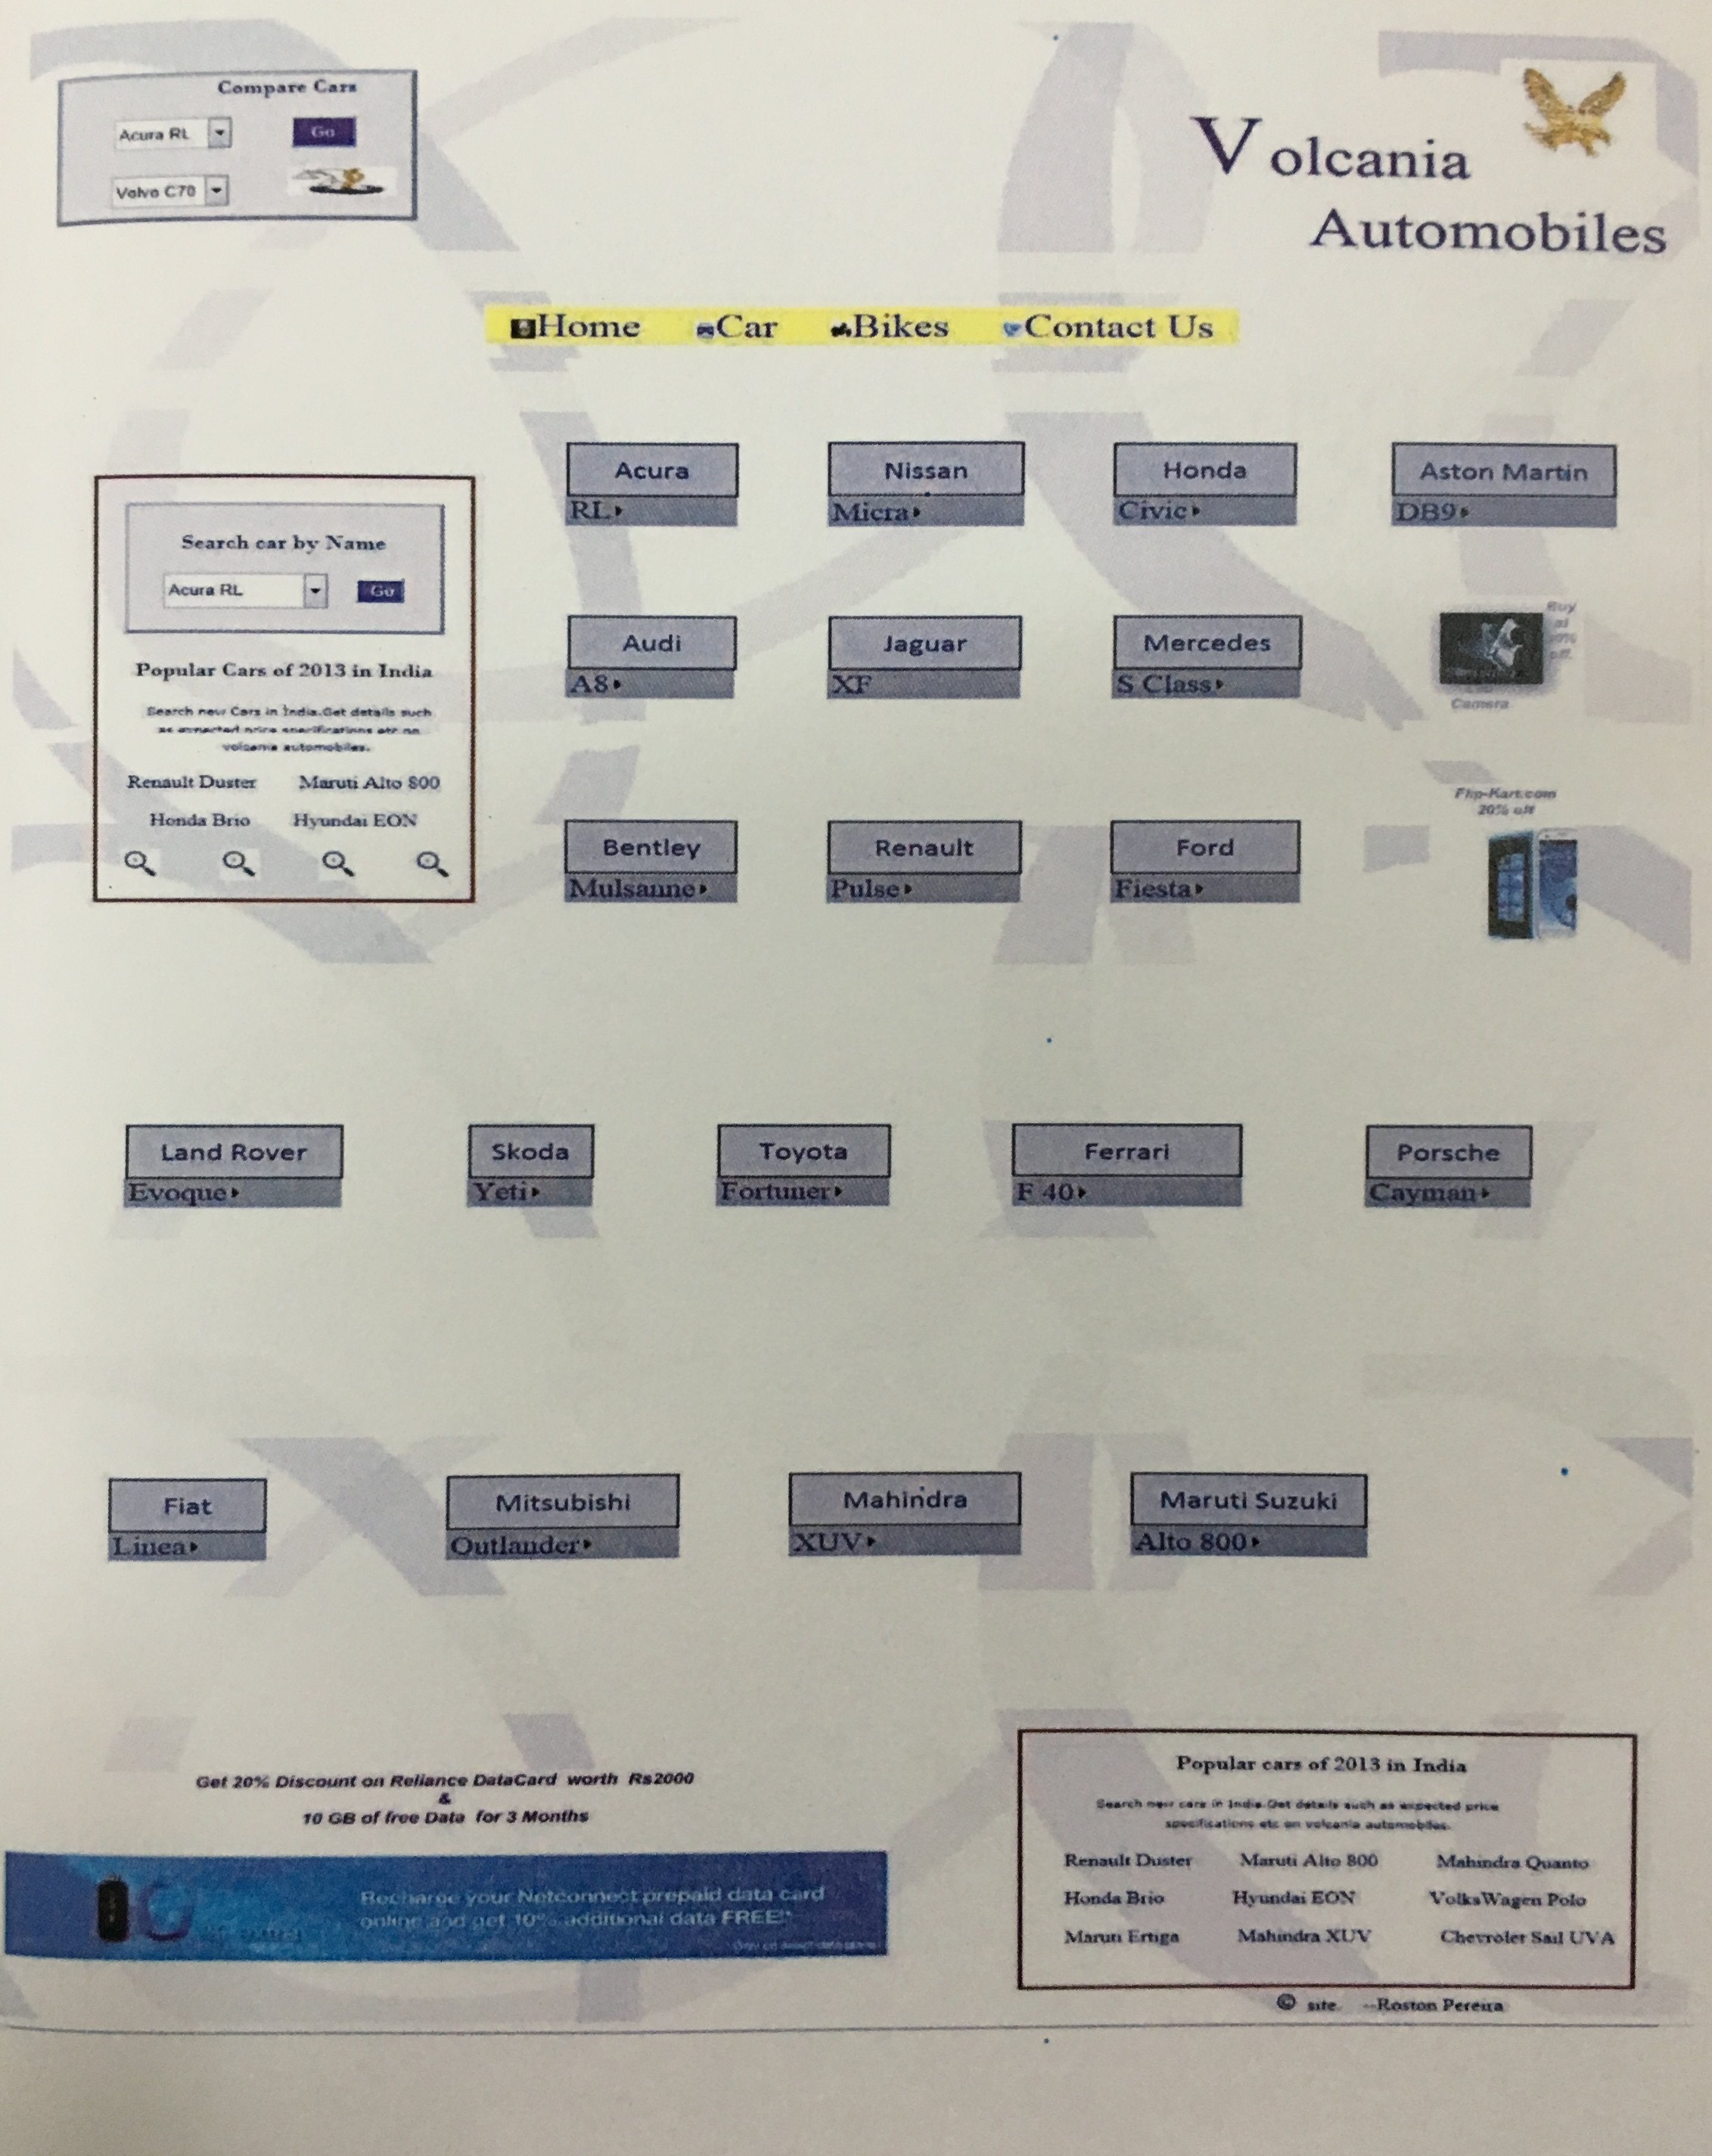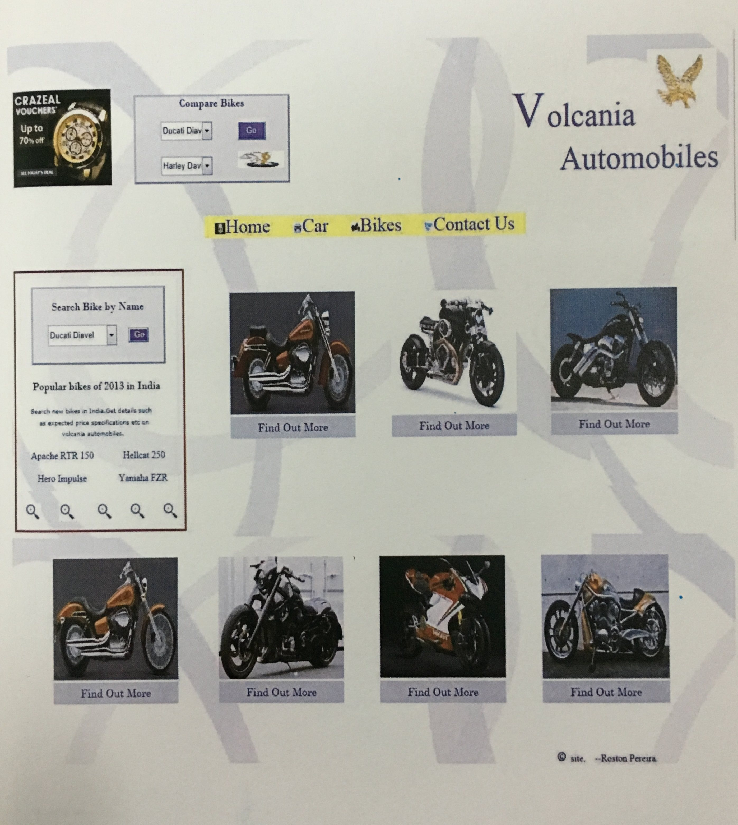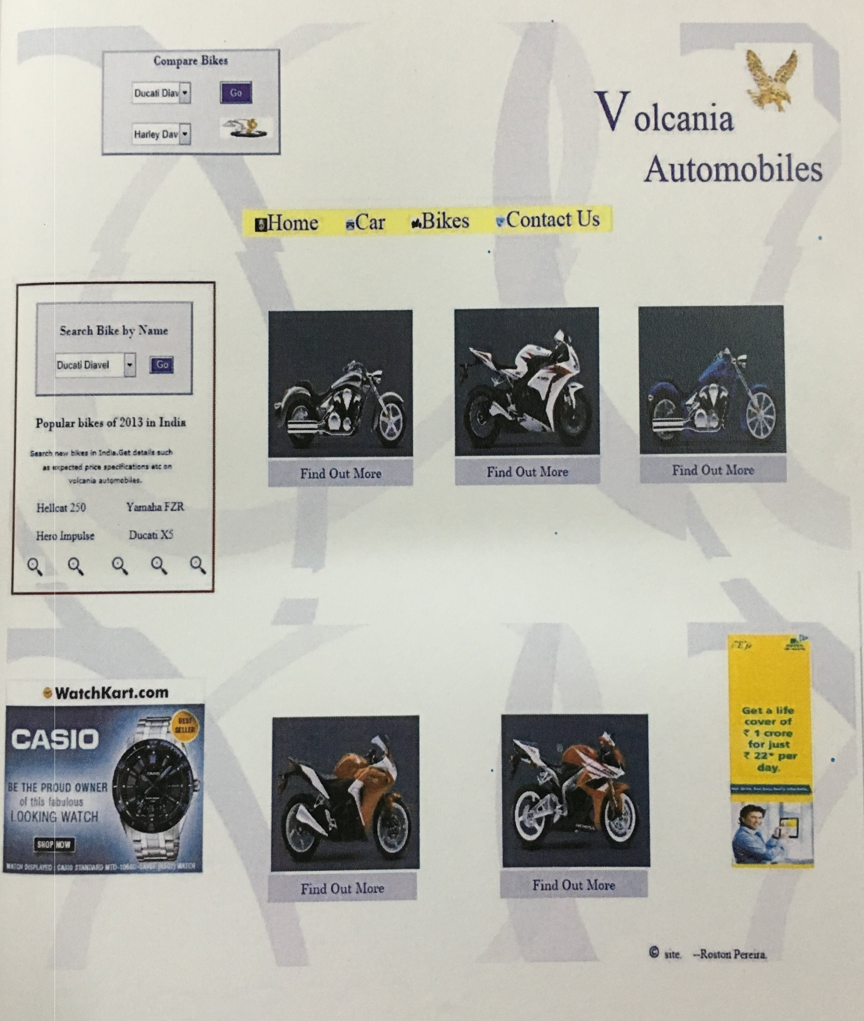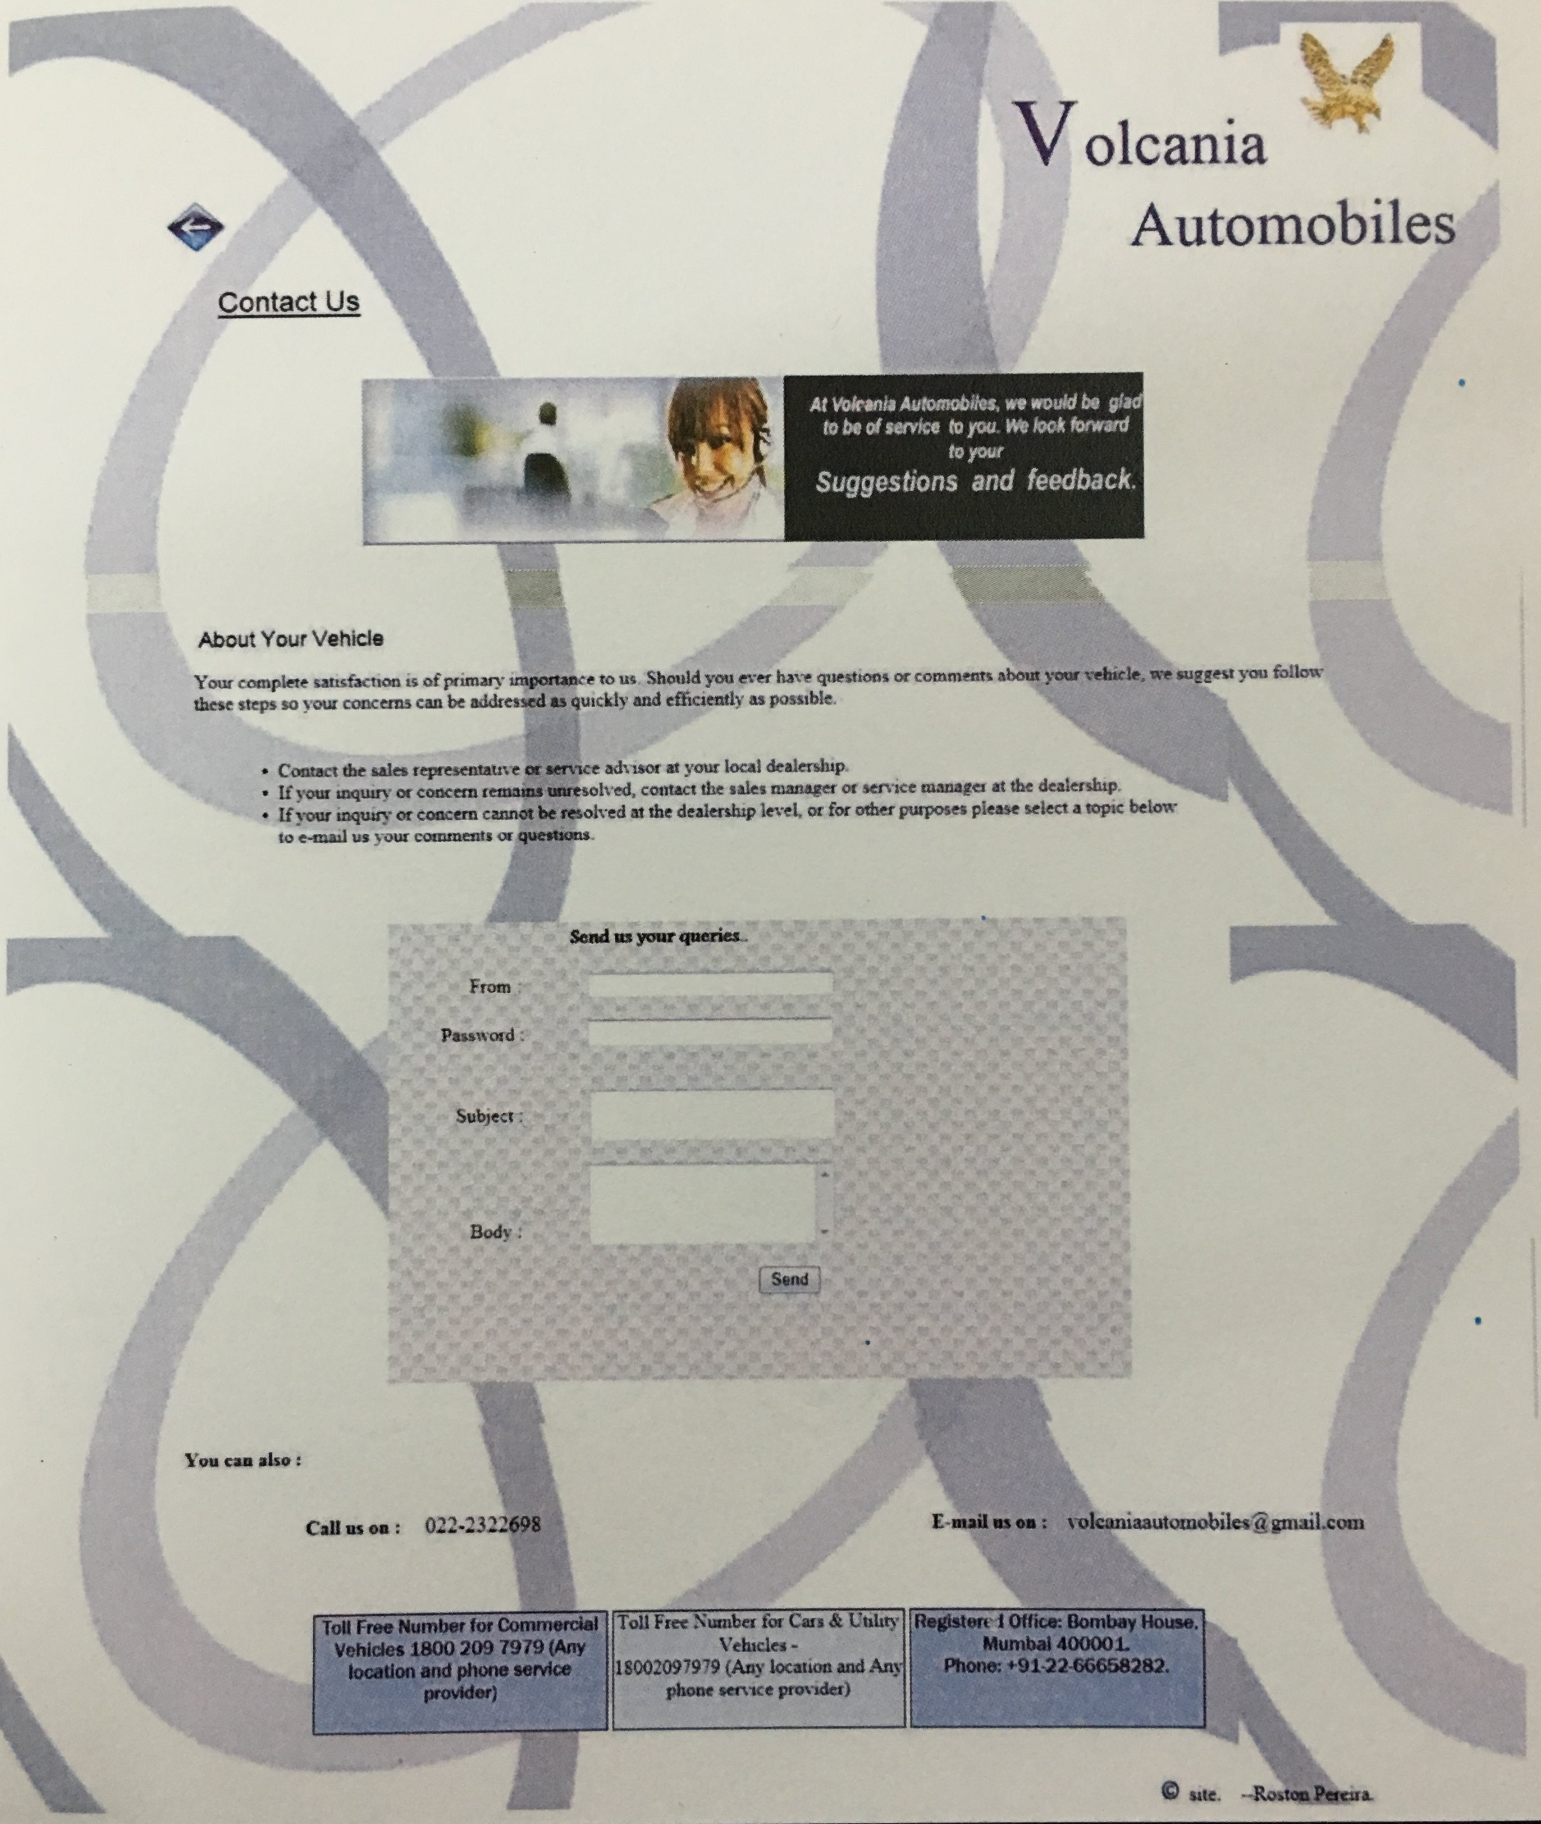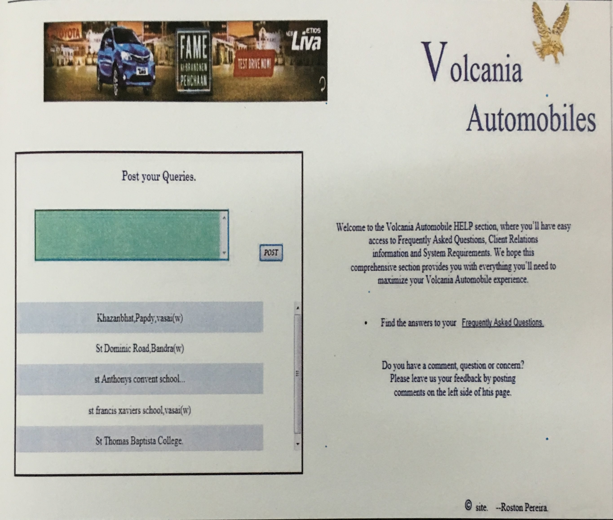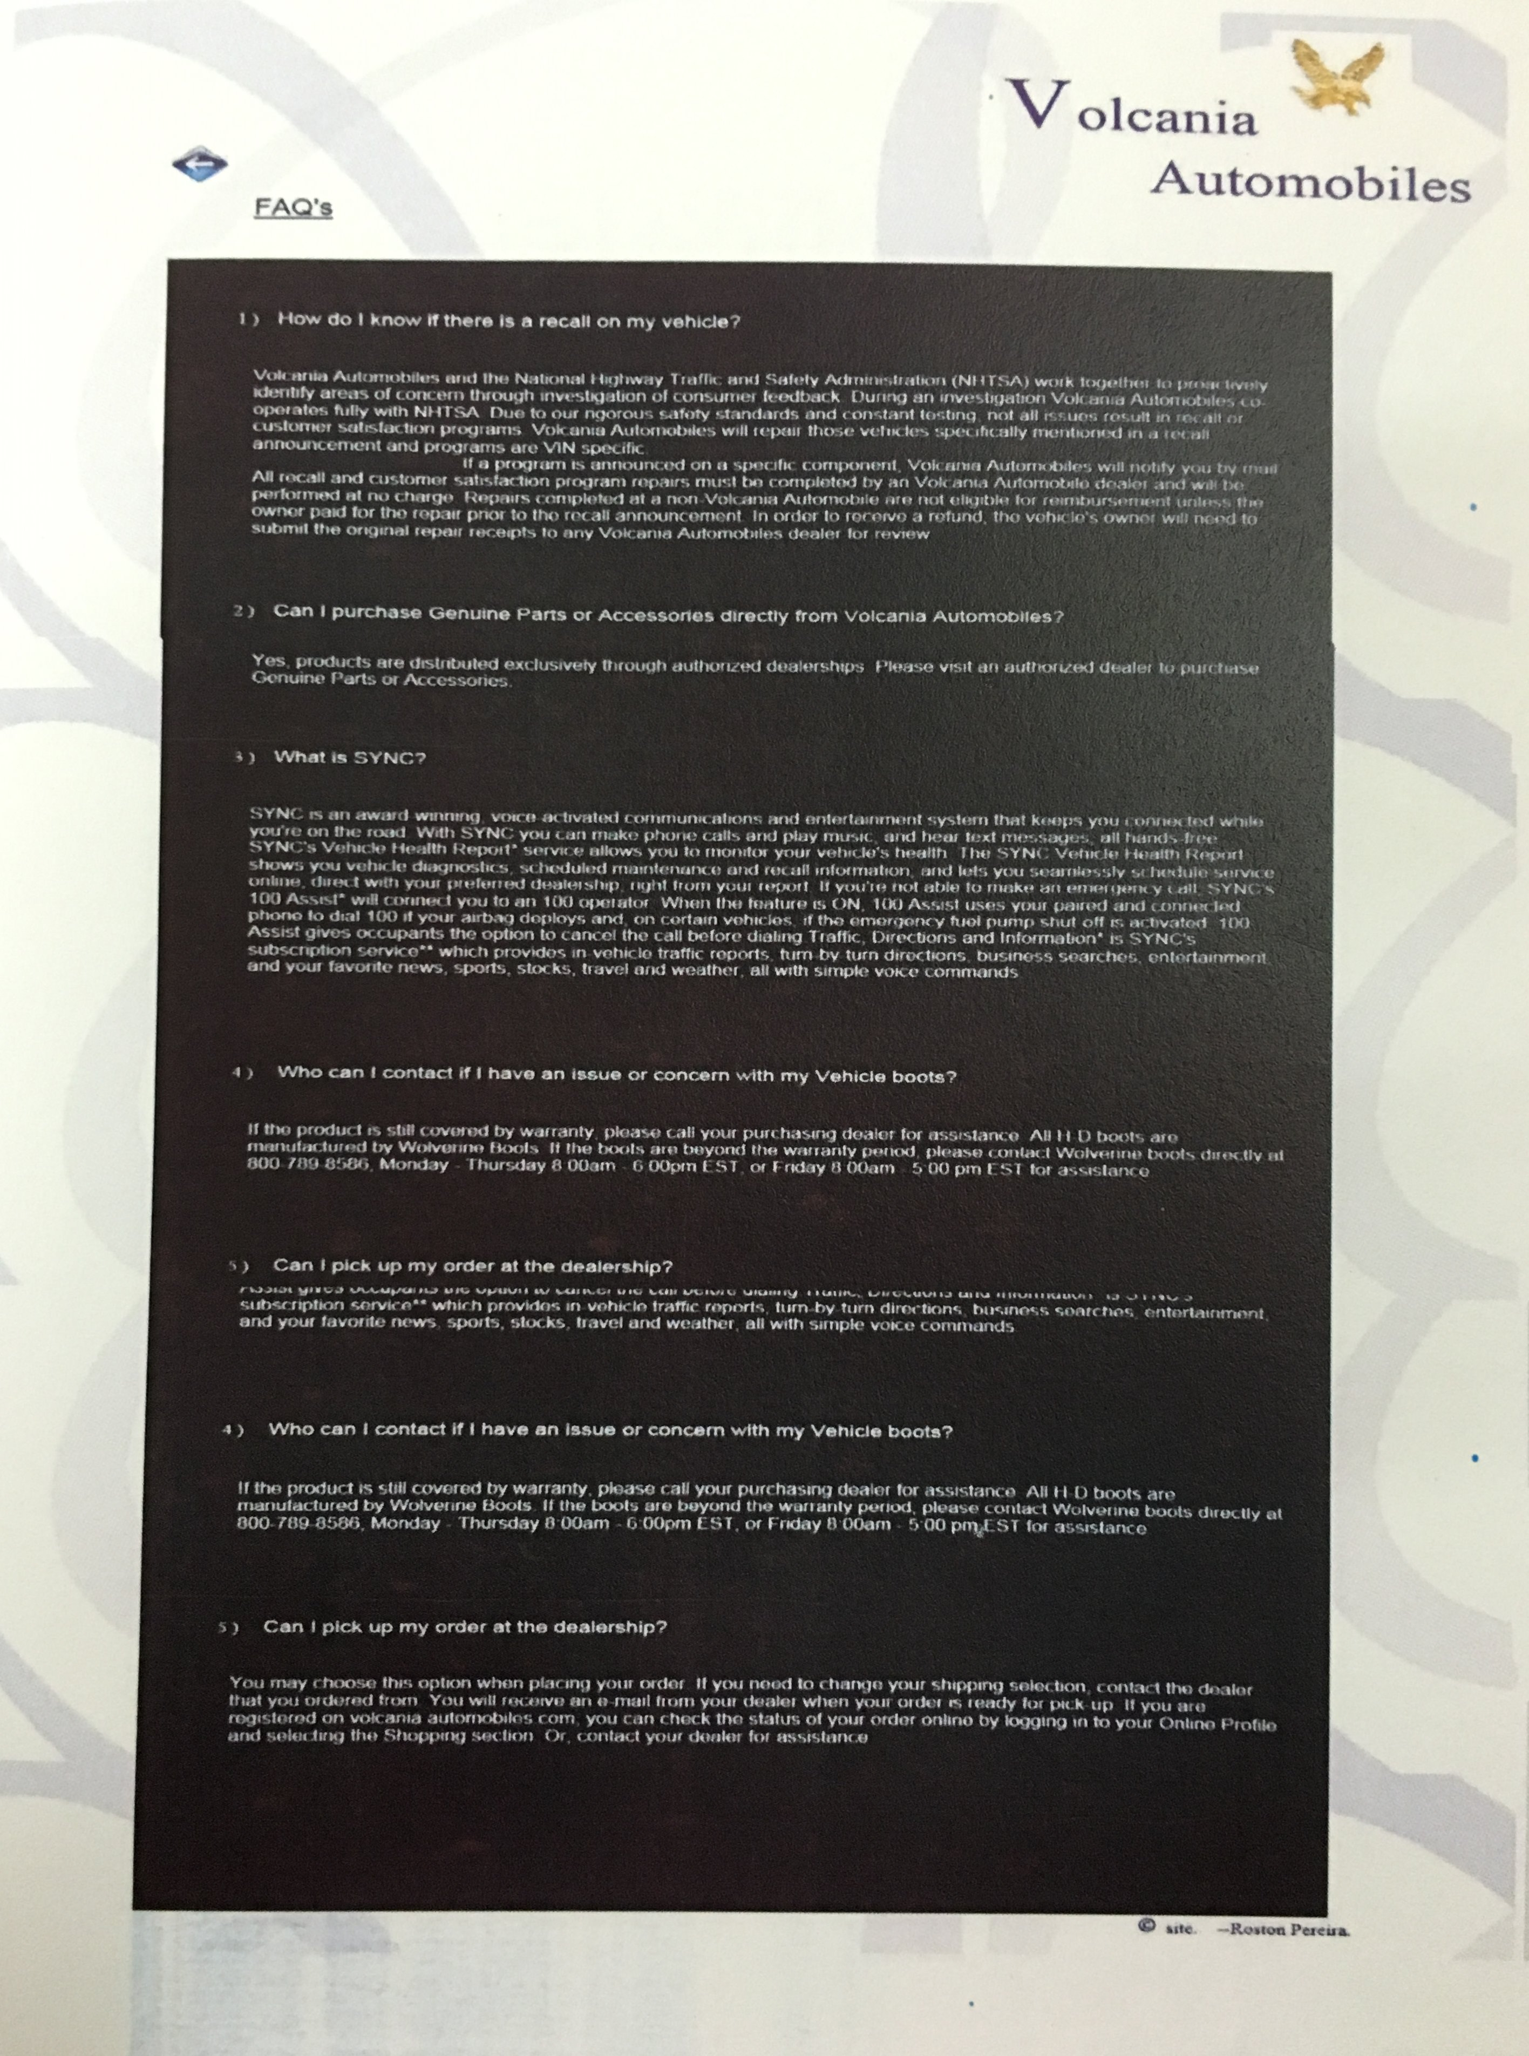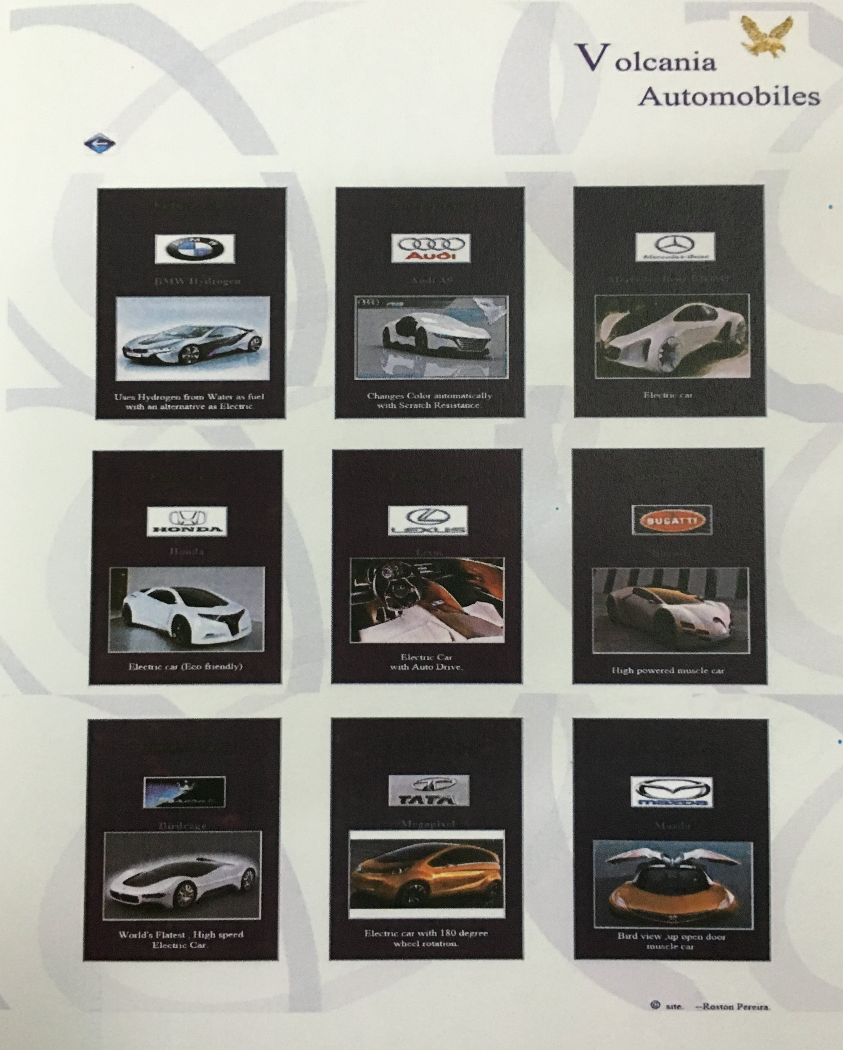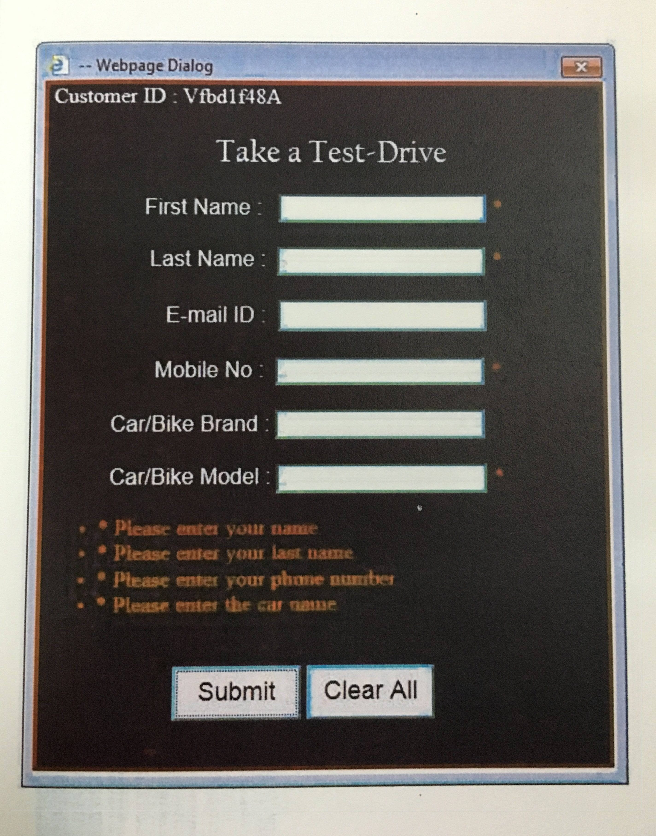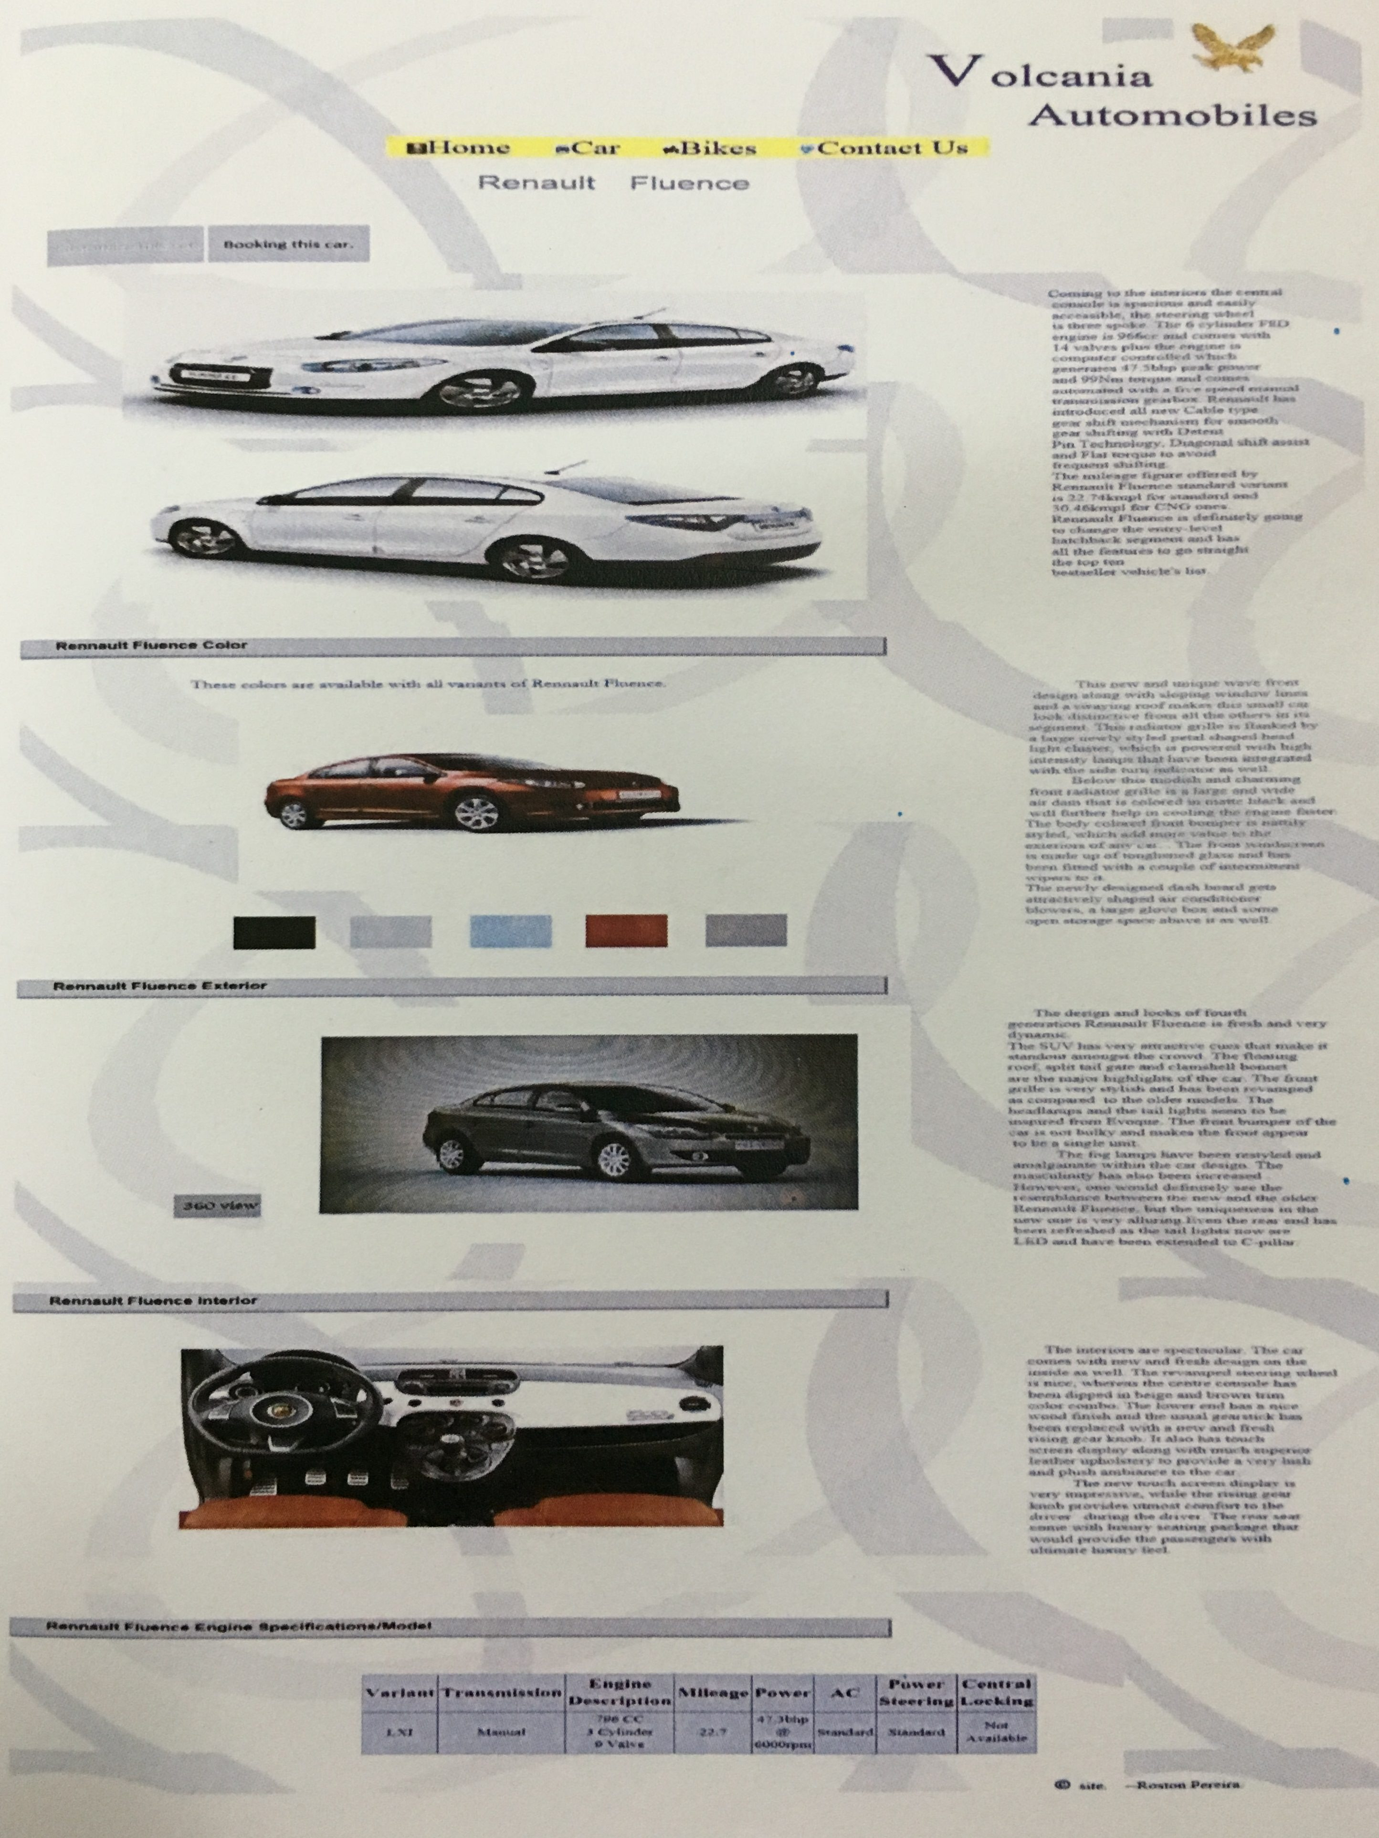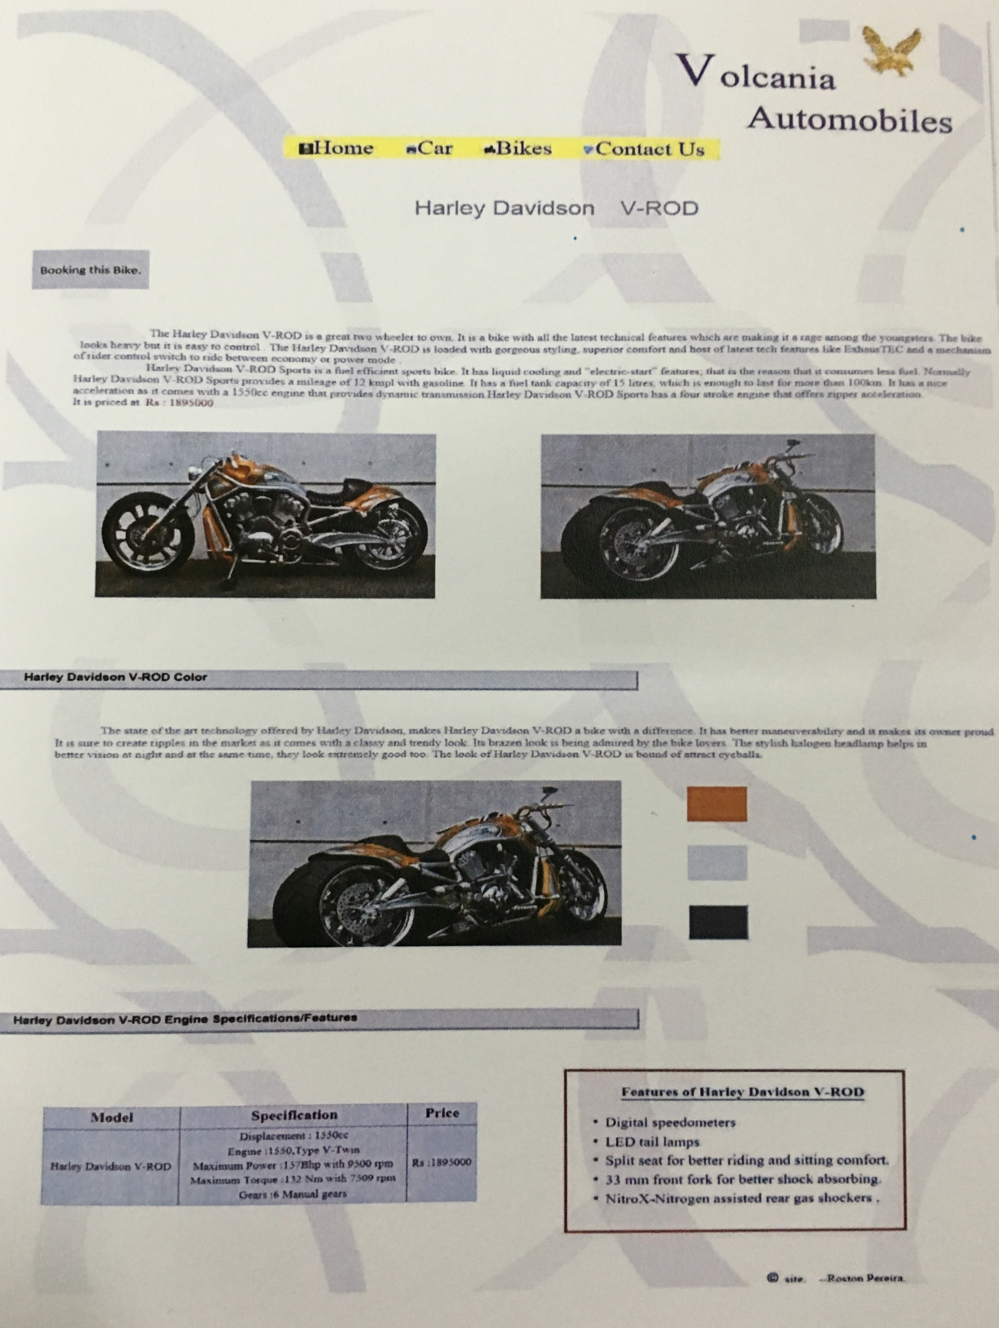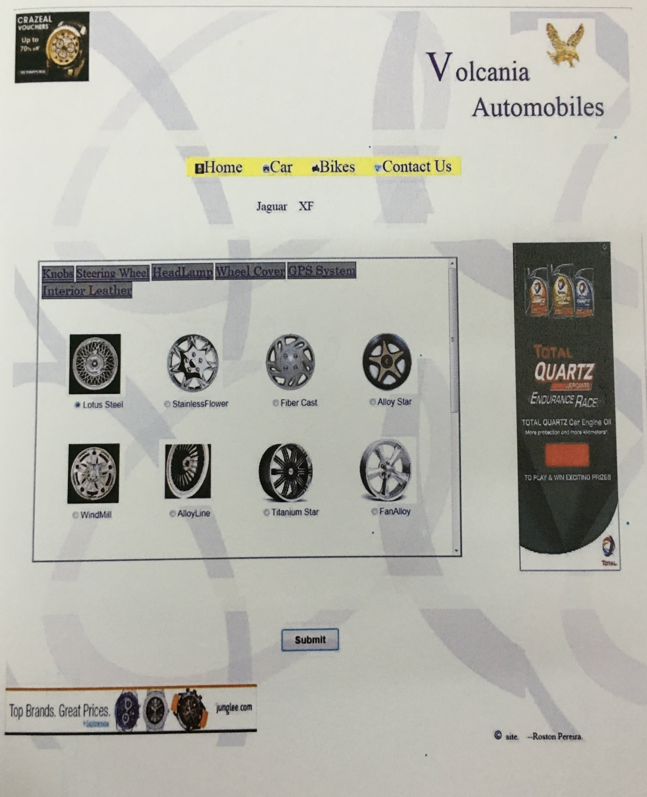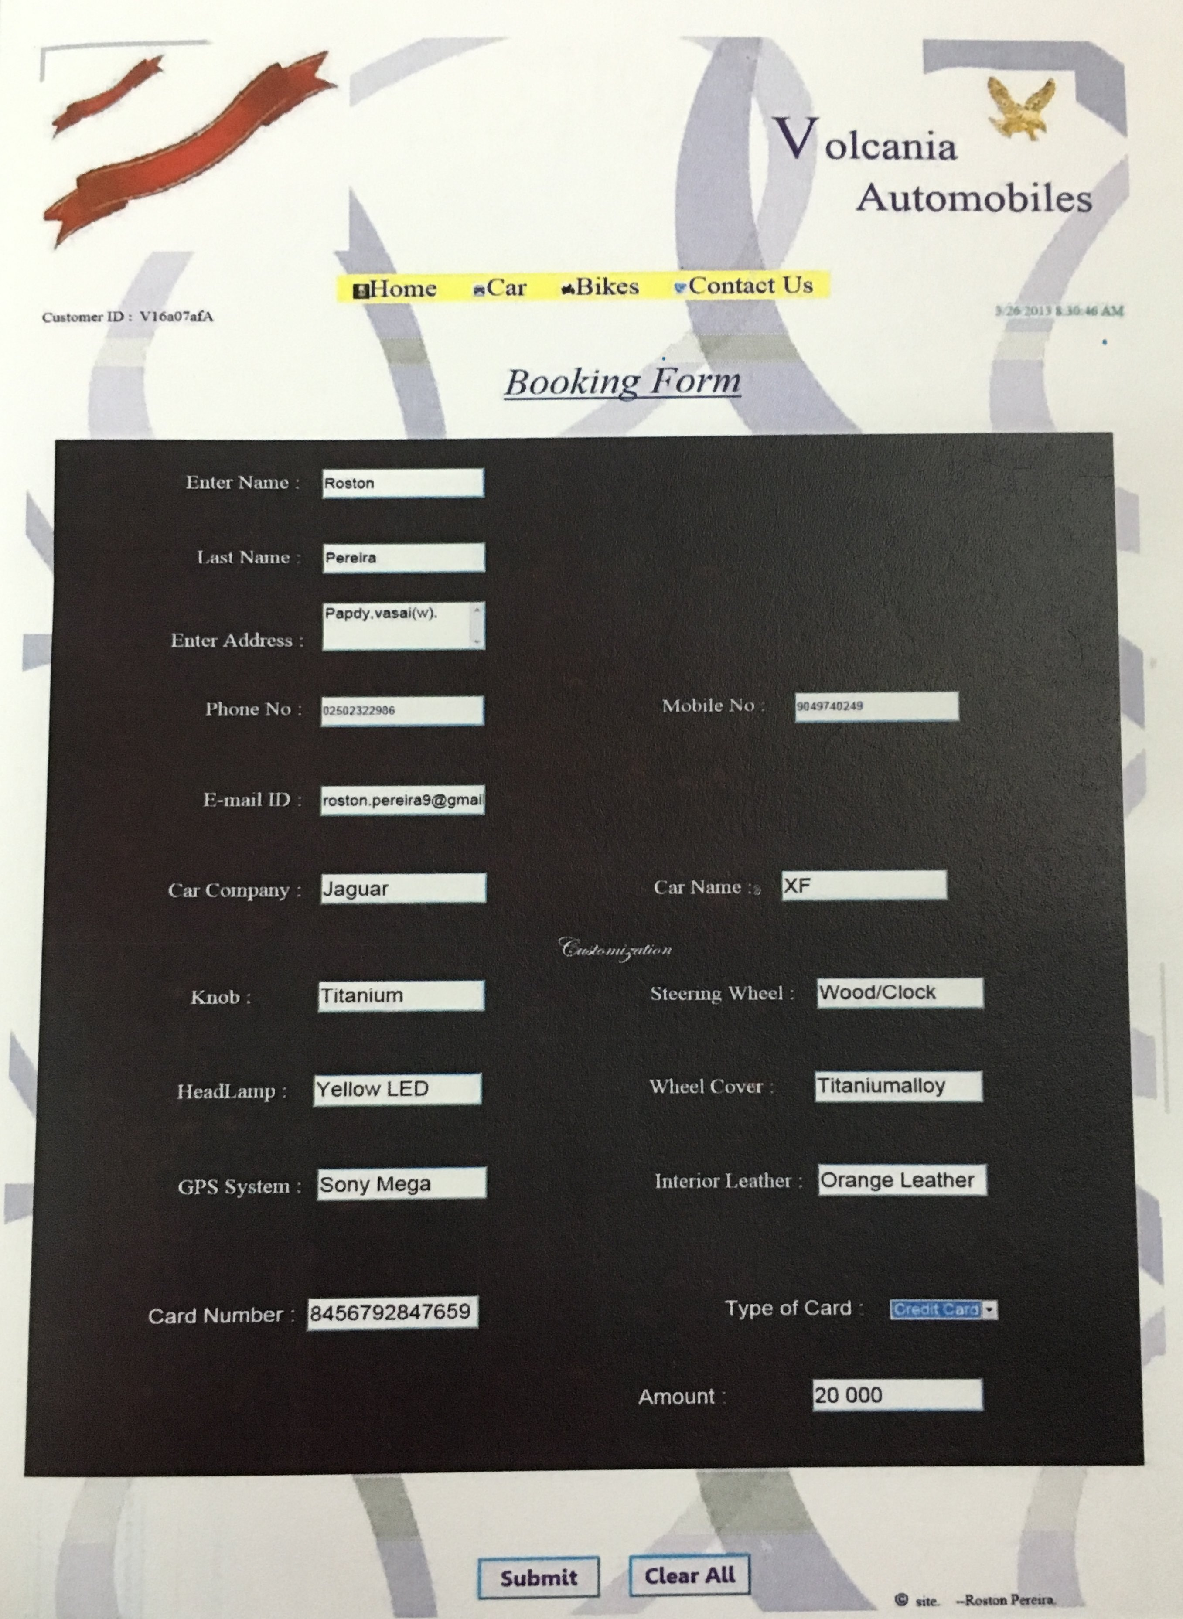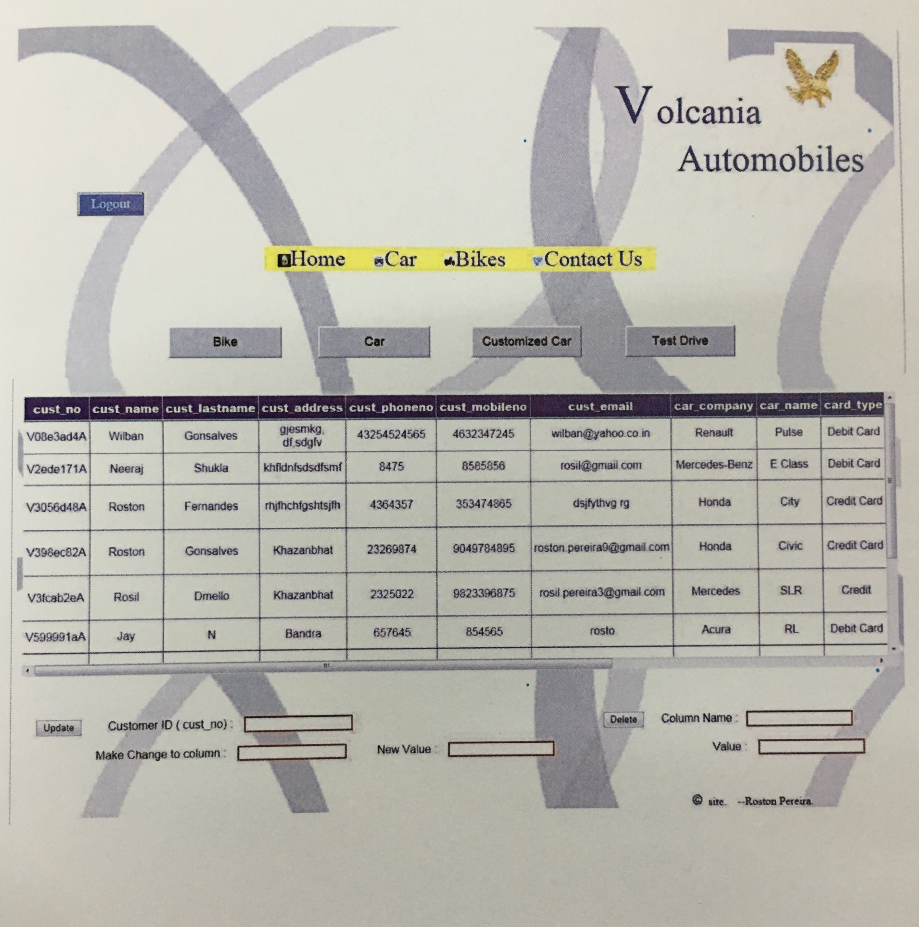

***User Manual***

1. Home Page

If you are a customer open the website from your personal computer, a home page gets displayed. The user/customer can select from cars/bikes whichever desired from the menu. The customer/user can also get information about future innovations by selecting the “**Innovation**” tab from the menu. Customer can get contact details for further communication from the “**Contact us**” tab from the menu.

1. Test Drive

If the customer desired to book for a test drive for a particular vehicle he/she can do so by clicking on the link on the home page (i.e. below the center image). The user has to give in his/her details including the phone number, E-mail id etc.

1. Car Booking

A customer/user can select from the menu either sports or luxury cars whichever desired, by clicking on the respective tab the user gets a webpage which displays a list of companies and the car models available of that company. The user can select a car by clicking the tab of the respective car and view all its details including the colors, engine specifications etc. The user can compare two different cars (either of same company or different) and get the details by selecting two cars from the dropdown list and then pressing the “**Go**” button.

The customer has an option of customizing a car (available only for select companies) form the car details page press the top left button i.e. “**Customize this car**” a customization webpage occurs, the customer/user can select from a list of options and then press “**Submit**” button, it will redirect to a booking page, just fill-in all the details and press “**Submit**” button.

1. Bike Booking

A customer/user can select from the menu either sports or non-sports bikes whichever desired, by clicking on the respective tab the user gets a webpage which displays a list of bike models available. The user can select a bike by clicking the tab of the respective bike i.e. “**Find out more**” and view all its details including the colors, engine specifications etc. The user can compare two different bikes (either of same company or different) and get the details by selecting two cars from the dropdown list and then pressing the “**Go**” button.

The customer can book a bike by clicking the top left button “**Book this Bike**”, it redirects to a booking page, the customer then has to fill all details and press “**Submit**” button.

1. Logging In

If the user is an Administrator, login from the homepage by entering the username and password in the respective textbox i.e. to the bottom left of the homepage. After logging in the software redirects to a database page where all the details of booking, test drive requests etc. are displayed in a tabular format.

1. Update / Delete

An administrator can make changes to the records by entering the older records and the new once which will replace the existing once. In the “**column name**” textbox put the name of the older column and in the “**old value**” textbox put the existing value i.e. older value. Then in the “**Make change to column**” textbox put the name of the column of which the record has to be changed or updated, in the “**new value**” textbox put the new value i.e. the value which will replace the older records and then press the “**update**” button.

If any record has to be deleted just enter the column name in the “**Column name**” textbox and the value either the “**Customer unique no**” or any unique value in the “**Value**” textbox.

1. Logging Out

To logout of the database page just click on the “Logout” button on the top left corner.

***Future Scope***

This application can be easily implemented under various situations. We can add new features as and when we require. Reusability is possible as and when required in this application. There is flexibility in all the modules.

*Software Scope:*

Extensibility:

This software is extendable in ways that is original developers may not expect. The following principles enhance extensibility like hide data structure, avoid traversing multiple links or methods, avoid case statements on object type and distinguish public and private operations.

Reusability:

Reusability is possible as and when require in this application. We can update its next version. Reusable software reduces design, coding and testing cost by amortizing effort over several designs. Reducing the amount of code also simplifies understanding, which increases the likelihood that the code is correct. We follow up both types of reusability.

Understandability:

A method is understandable if someone other than the creator of the method can understand the code (as well as the creator after a time lapse). We use the method, which small and coherent helps to accomplish this.

Cost effectiveness:

Its cost is under the budget and make within given time period. It is desirable to aim for a system with a minimum cost subject to the condition that it must satisfy the entire requirement.

Future Additions:

* Can be converted to fully functional management system with some modifications.
* Additions of SMS facility to this project will add to its efficiency.
* Vehicles can be added.
* Making the full software dynamic.
* Collaboration with different banks for monetary transactions.

Scope of this document is to put down the requirements, clearly identifying the information needed by the user, the source of the information and outputs expected from the system.

***Conclusion***

From a proper analysis of positive points and constraints on the component, it can be safely concluded that the product is a highly efficient GUI based component. This application is working properly and meeting to all user requirements. This component can be easily plugged in many other systems.

In .NET framework the overall system and architecture is very well framed and ready to be utilized in whatever shapes the application demands. The system’s convenience and the case is enjoyed and admired by all the developers who are using .NET for developing applications. .NET platform adds powerful automated controls with built-in functionality and provides the developers a complete line of support they even desire and this is the main reason that we achieved the goal of completing this application framework. With code optimization, database design and structure optimization and compressive caching techniques, performance monitoring and the compiled code running on the server. ASP.NET offers enhanced performance before a single line of the code ever written for the application. Rich collection of controls including web server controls with ideal integrated development environment with strong and real time database functionality for web application development (Visual studio .NET) gives the web developer maximum convenience accompanied with minimum development time.

During the process of building this application we learned and practiced many new techniques that we found very useful and interesting in the context of building a powerful business website.

***Bibliography***

* A programmers Introduction to C# - 2nd Edition – Eric Gunnerson
* C# Programming Language (Covering C# 4.0) – Anders Hejlsberg
* C# Essentials, 2nd Edition (O’Reilly) – Ben Albahari, Peter Drayton
* Murach’s SQL Server 2008

***References***

* [www.stackoverflow.com](http://www.stackoverflow.com)
* [www.social.msdn.microsoft.com/forums/VisualStudio](http://www.social.msdn.microsoft.com/forums/VisualStudio)
* [www.forums.asp.net/t/prev/1782829](http://www.forums.asp.net/t/prev/1782829)